




Board Of Trustees Application Pack- (Secretary)

Support & Enquiry: 01382 201291
info@wrasac.org.uk
support@wrasac.org.uk
www.wrasac.org.uk

05/02/2026
Hello
We are delighted that you are considering a role with WRASAC as a member of the Board of Trustees/Governor (BOG).
Demand for service continues to grow and whilst we have been successful in securing funding to increase our services capacity the work does not stop there! We have quite a task ahead of us in 2026 and want to explore new ways of working, develop our fundraising capability as well as exploring other funding opportunities
If you decide to apply and get involved you will become part of a dynamic, essential service in Dundee and Angus. You will be helping to support the work of the managers and staff who support survivors, who have experienced child sexual abuse, rape, sexual assault or/and sexual exploitation at any time in their lives.
This pack is designed to give you a background about our service and give you a better idea about what the role of BOG member will entail.
Please don’t hesitate to contact our CEO Katie Hardy-Jensen, on (01382) 201291 if you would like any further information.
You can return your application by e-mail to recruitment@wrasac.org.uk or alternatively you can post your application to Ground Floor, No 4 Chambers Building, Panmure Street, Dundee DD1 1EP
We look forward to hearing from you soon.

Please note only women need apply under Schedule 9, Part 1 of the Equality Act 2010.

Ground Floor, No 4 Chambers Building, Panmure Street, Dundee DD1 1EP
WRASAC Dundee & Angus is a company limited by guarantee, registered with OSCR and registered in Scotland as company number SC241372 and charity number SC009070.




Information about WRASAC

The Women’s Rape and Sexual Abuse Centre – Dundee and Angus (WRASAC) have been supporting survivors of rape, sexual abuse and exploitation and raising awareness about the damaging effects of sexual violence since 1984. We are a registered charity and a company limited by guarantee.

We provide a range of services to survivors of sexual violence, abuse and exploitation including:
Women’s Support Service (WSS)
The Women’s Support Service provides support to women (over 18) who have experienced rape, sexual abuse and/or exploitation.
Support can include 1:1 session in the centre or on outreach, advocacy support and signposting to other organisations for support.
Initial Referral Team (IRT)
The Initial Referral Team provides that initial support to women and young people accessing support from WRASAC. They will complete an introductory session to try and assess the needs of each person and either referral onto one of our own services, warm refer and support to another service or engage with survivors through here and now support to try and establish some safety and support for them. The initial referral team also cover the support and enquiry line and handle the referrals that come into service.
Dundee and Angus Young Survivors (DAYS)
We support all young people of any gender aged between 8 and 18 who live in Dundee or Angus and have experienced any type of sexual abuse.
We take a flexible approach to planning support to best meet the needs of the young person, this can be school, home, community or at our office.
1:1 Support - We offer emotional support to survivors. Each session is a safe and confidential space for survivors to process the trauma they have experienced at their own pace. We do this by using a range of therapeutic interventions and tools which are survivor centred.
Group work support - We various creative groups and peer support groups all of which aims to reduce isolation and extend social circles. The aim of these are to build survivors support networks and build survivors confidence, reducing isolation and feelings of blame and shame.
Family and Friends
We can also provide support to family, friends, partners and agency workers to help them understand the impact of sexual violence and cope with their feelings whilst supporting a survivor.
Vice Versa
Vice Versa provides support to adult women who have been involved, are currently involved or are at risk of being involved in Commercial Sexual Exploitation (CSE). The women we support generally experience multiple disadvantage which may include substance use, homelessness, physical and mental health issues, welfare issues and extensive historical and ongoing trauma.
The aim of the project is to provide women with safety and stabilisation support and with all issues that impact on their involvement in CSE. Support can include 1:1 session in the centre or on outreach, supporting to attend appointments and groups, advocacy support and signposting to other organisations or support. Support is led entirely by the women and their needs and priorities.
Justice Advocacy Service
Our Justice Advocacy Service provides support throughout the criminal justice process. We can support survivors with their decision to report the incident to the Police or not.

If they decide to report to the Police, we can go with survivors while they provide their statement and if they would prefer, we can get updates on the investigation from the Police on survivor’s behalf.

If the case is reported to the Crown Office and Procurator Fiscal Service (COPFS), we can liaise with survivors assigned Victim Information and Advice Officer (VIA) and talk to them about special measures that can be put in place to make giving evidence as easy as possible.

Advocacy Workers can go into the court room with survivors (as an In Court Supporter) while they give evidence, and they can provide support around verdicts and sentencing.

Advocacy workers can also provide post court support to survivors.

Dundee Women’s Hub
WRASAC supported by partners across the Dundee area are responsible for the setting up, development and facilitation of Dundee Women’s Hub (DWH).

The main aim of the DWH is to increase capacity and co-ordination of services to respond to the needs of the women experiencing substance use and multiple disadvantage. The hub will improve access to substance use and related services for women in Dundee with the overall goal of improving physical and emotional wellbeing for women who experience substance use and multiple disadvantages.

Prevention Work
We have a dedicated Prevention Worker(s) who works in schools, colleges and youth settings in Dundee and Angus delivering the Rape Crisis Scotland Prevention Pack.
Gender Based Violence (GBV) Team
The GBV Team is made up of a Community Engagement Worker who focuses on increasing access to our service and raising awareness around our service and issues related to sexual violence.
Two Learning and Development Officers who are co-located between WRASAC and Dundee City Council who provide training and support and strategic direction in relation to GBV and Trauma across the VAWG network and council in Dundee
Training and Awareness Raising
Staff across our teams provide training sessions We provide WRASAC Information Session’s to staff from Dundee and Angus. We also provide training on a range of topics including understanding sexual violence and dealing with trauma. Additionally, we run community awareness raising events, like our Reclaim the Night March each year.

Vision, Values and Strategic Priorities

Our Vision
For a world free from sexual violence, abuse and exploitation and a society in which everyone has equality, freedom and choices to live the lives they want and thrive.

Our Mission
To support survivors who have experienced any form of sexual violence, abuse or exploitation in their lives.
To promote equality and raise public awareness of the routes of sexual violence and its damaging and life-changing effects.

Our Values
We believe first and foremost that perpetrators of rape, sexual abuse and exploitation are responsible for their actions – not survivors.

We are a feminist organisation which means we recognise that all forms of rape, sexual abuse and exploitation are acts of violence, that disproportionately affects women and children, involving the abuse of power and control, are a breach of human rights and are fundamentally rooted in gender inequality.

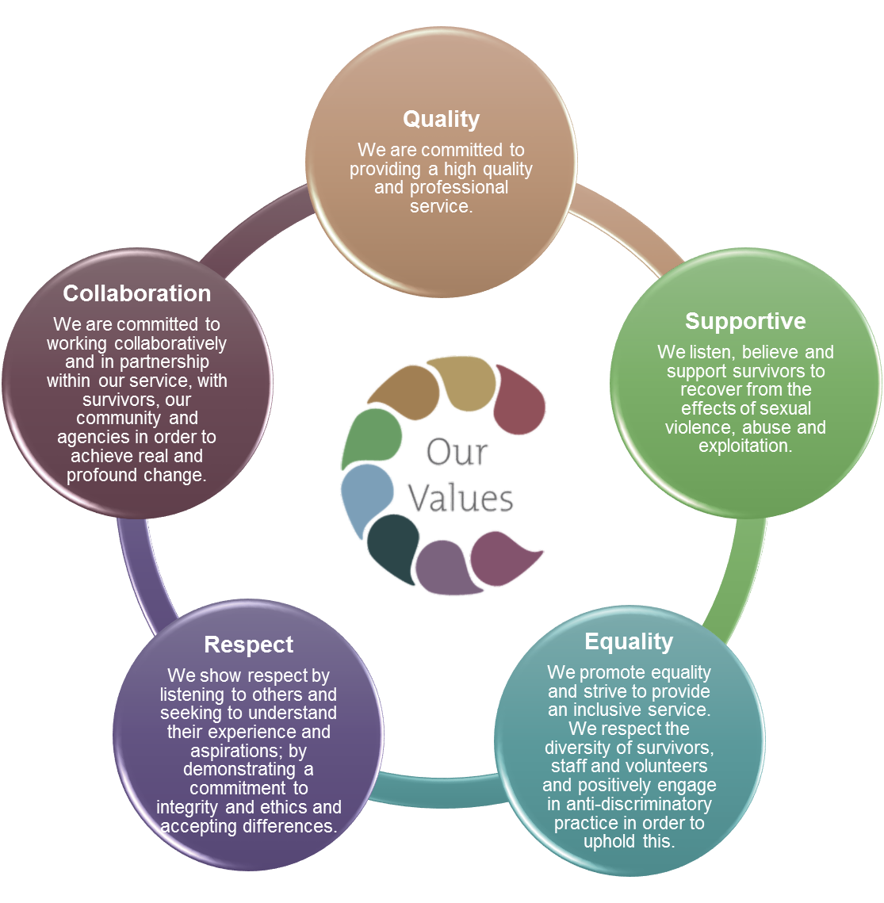

Our Strategic Priorities

Why we need you!
We have been facing many challenges over the past few years adapting our services to work differently through COVID and now looking at what this looks like in the future. We continue to see an increase in the demand for support services and have been able to evidence the need to grow our service. We have had some funding success in the last year to increase service capacity and as such we would like to grow our board to ensure that we can meet the demands of WRASAC and ensure that we continue to provide a high-quality service that meets survivors needs

Board of Governor’s Role
Responsible to: WRASAC CEO & Chair of Board
Purpose: The role of the Board is to safeguard and promote the values and mission of the Centre, to determine the strategy and structure of the Centre, to ensure the Centre operates in an effective, responsible and accountable manner and to ensure the effective functioning of the board
Board Secretary Role
The secretary is a trustee with a specific role on the board. As a trustee, the Board Secretary will contribute to the work of the board and participate in discussion of papers and debates within meeting and have full voting rights. The Board Secretary has key responsibilities and duties.
Key Responsibilities are
- Organising of monthly board meetings and Annual General Meeting (AGM) and any Exceptional General Meetings (EGM)
- Support the preparation and circulating of the monthly board meetings and AGM and any EGM agenda and papers.
- Take minutes of the monthly board meeting and AGM, and any EGM that are called and circulate draft to trustees within 3 working days of the meeting.
- The Secretary will need to make sure that:
- there are spare copies of all documents needed for the meeting
- arrangements for any vote or poll which may be needed are in place
- the meeting is properly convened
- there is a quorum (and if required, that it is present throughout the meeting);
- apologies for absence are noted, and
- all decisions made at the meeting are recorded in the minutes (if the result of a discussion is unclear, clarify decisions with the Chair during the meeting to ensure the minutes are accurate)
- If it appears that a matter has been overlooked, the Secretary should also draw this to the attention of the Chair.
- Update the action list after each board meeting.
Time Commitment
Board of Government estimated time commitment 4-8 hours per month dependent on the projects you align yourself to.
Board meetings Approx. 2 hours per month
Budget/Finance/Subgroup meetings Approx. 0-2 hours per month
Preparation for these meetings Approx. 1-2 hours per month
This is an approx. guide; 4 hours is the minimum time commitment per month. Where issues arise, events take place, funding is applied for etc there may be a larger time commitment that month.
Board Meetings are usually held on the 4th Wednesday of every month from 17.30-19.00/19.30 and are currently a mix between face to face and online meetings.
Expenses
WRASAC offers travel, childcare, dependent care costs and other relevant out of pocket expenses in line with WRASAC’s finance policy.
The following information is from the Ensuring Good Governance Rape Crisis Scotland – Information pack

The responsibility of the board members*
1. To safeguard and promote the values and mission of the Centre
• to understand, be committed to, and promote the aims and strategic objectives of the Centre and its core values as set out in the strategic plan
• to ensure the centre acts in line with its governing document, charity and company law (if appropriate) and all other relevant legislation
• to ensure organisational practices comply with Centre’s values, strategic objectives and its governing documents
2. To determine the strategy and structure of the Centre
• to work with staff to produce a strategic plan that meets the organisation’s agreed aims and intended outcomes
• to monitor, review and update the strategic plan to ensure it is fit for purpose
• to ensure the centre has an appropriate structure in terms of governance, management and operation to meet its agreed aims and objectives
• to work with staff to develop a business plan which sets out a programme of activities that deliver the organisation’s strategic objectives
• to set and approve budgets to achieve the objectives established in the business plan and regularly monitor performance
3.To ensure the Centre operates in an effective, responsible and accountable manner
• to identify, establish, review and date policies and procedures required by law and to implement good organisational management and employment practices
• to ensure equality is main streamed within all Centre policies and practice
• to ensure the Centre is financially stable, and manages and accounts for its finances, assets and other resources efficiently in accordance with accounting and legal requirements
• to ensure the Manager is supervised, supported, and monitored
• to ensure paid workers and volunteer staff are inducted, supervised, supported, and monitored
• to consider carefully all information, advice, and reports presented, and request further information, including legal or specialist advice, where necessary
• to maintain and review the Centre’s system of delegated responsibility, internal controls, financial controls and performance reporting
• to ensure the accountability of the organisation as required by law to OSCR, the Inland Revenue, the Registrar of Companies, members, funders, and the public at large
4. To ensure the effective functioning of the board
• to work constructively with other board members to ensure they are an effective body acting in the interests of the Centre
• to specify in role descriptions the responsibilities and powers delegated to particular posts (e.g. Chair, Treasurer) or to any sub-group
• to recruit a board that reflects the membership and wider community that the Centre serves, and provides the range of skills and experience that the Centre requires to fulfil its objectives
• to take part in induction and other training identified by the board and/or manager
• to review and develop policies and procedures that determine the conduct of the board and its meetings
• to ensure conflicts of interest are declared and handled in accordance with policy
• to prepare for and attend board meetings and contribute to discussions and decision-making
• to keep informed of issues which affect the Centre, and promote the Centre externally as agreed with the board
• to participate in tasks as required over and above-board meetings
The Centre will support board members by providing
• induction, training, and opportunities for development
• regular, accurate and relevant information on all aspects of the organisation
• encouragement to question decisions and disagree in a constructive manner
• access to support and guidance to become more effective
Women’s Rape and Sexual Abuse Centre

BOG Member Application Form

Name:

Address:

Postcode:

Email:

Mobile / Daytime number
Role Interest | Secretary or Board Member

Please answer the following questions as fully as you are able.

(Please continue on another sheet if necessary)

What attracts you to becoming part of the Board of Governors?

What skills, experience, or personal qualities would you bring to our Board of Governors?

As a feminist organisation, and reflecting on our Vision, Mission and Values, how would you contribute to and uphold our feminist principles within this role?

What experience do you have—professional, voluntary, or personal—that is relevant to governance, strategic leadership, or supporting survivors of sexual violence?

Being on the Board requires approximately 4–8 hours per month. Can you tell us how you will manage this commitment?

Are you related to any employees/board members at WRASAC? Please provide us information

Have you been on the board at WRASAC previously? If yes please tell us when and more information

References: Please note these can be character references.

Please note we will contact referees prior to interview.

Referee name:

Address:

Postcode:

Relationship to applicant:

Referee name:

Address:

Postcode:

Relationship to applicant:

Signed:

Date:

Please contact WRASAC on (01382) 201291 if you have any questions about any part of this application.
Please return completed application to

e-mail to recruitment@wrasac.org.uk

