Access and Inclusion Worker
Business: 01382 205556
Support: 01382 201291
Text: 07515288171
info@wrasac.org.uk
support@wrasac.org.uk
www.wrasac.org.uk

Dear Applicant

Thank you for your interest in applying for a post with Women’s Rape and Sexual Abuse Centre. Please find enclosed the following documents:-

- Advice on completing your application form
- Information about WRASAC
- Job Description and Person Specification

Please do not send a curriculum vitae as this will not be considered.

Please note, all applications and relevant recruitment documents will be held confidentially and destroyed after 6 months, apart from documents relating to the successful applicant.

Your completed application should be submitted via email by sending it to recruitment@wrasac.org.uk.

Closing Date is Monday 22nd March 2021 at 5pm

Interviews will be held on Wednesday 31st March 2021 via zoom.

Please note this post is 28 Hours per week and is temporary to June 2022. The post may become permanent if application for additional funding is successful.

We would appreciate it if you would take the time to complete this equal opportunities survey: Click Here

We look forward to receiving your completed application form. Enquiries about this position are welcome by phoning or emailing Sandra Ormeno or Helen Hampton.

Yours sincerely
Kristina Piggott
Deputy Manager

Sangobeg House, 4 Francis Street, Dundee, DD3 8HH
WRASAC Dundee & Angus is a company limited by guarantee, registered with OSCR and registered in Scotland as company number SC241372 and charity number SC009070.
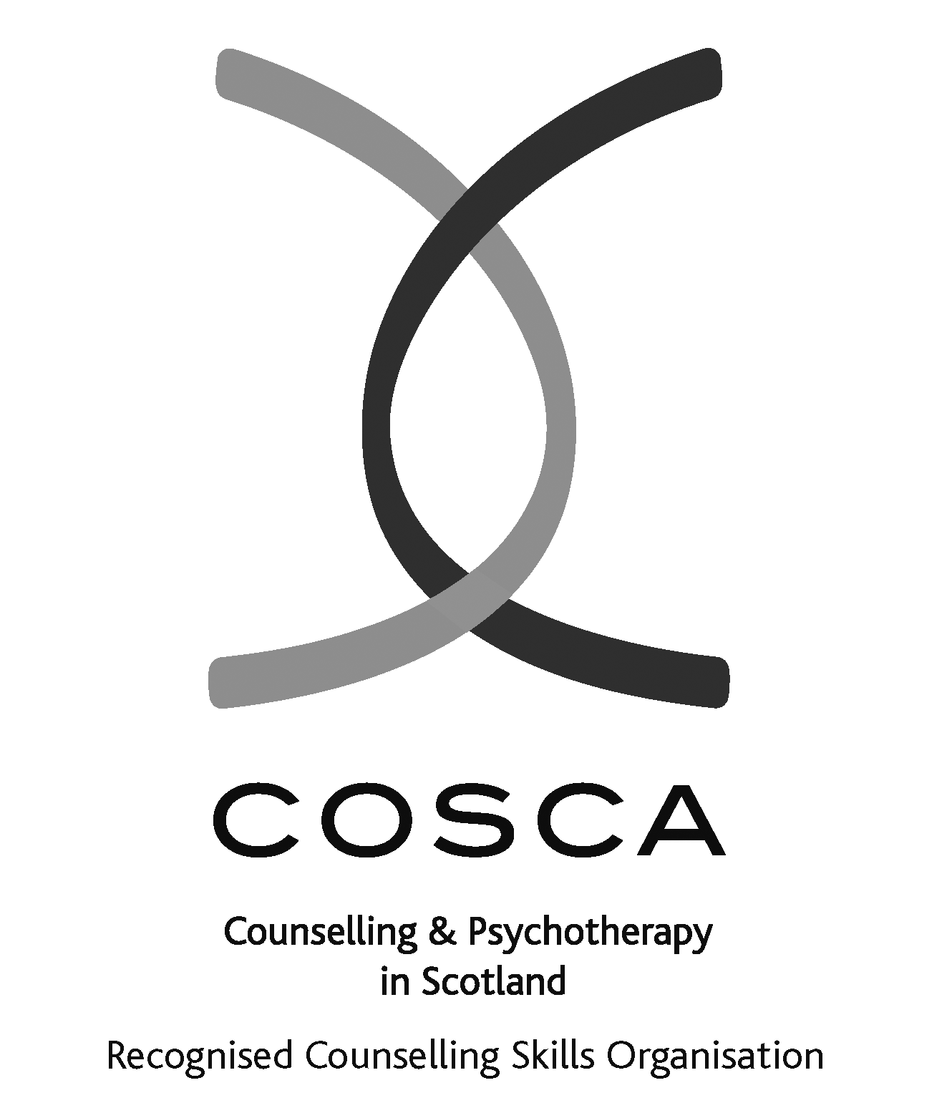
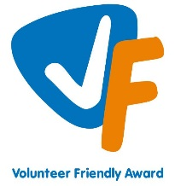

About our service

The Women’s Rape and Sexual Abuse Centre – Dundee and Angus (WRASAC) has been supporting survivors of rape, sexual abuse and exploitation and raising awareness about the damaging effects of sexual violence since 1984. We are a registered charity and a company limited by guarantee.
WRASAC has a dynamic team of 15 staff members, 12 volunteers and an annual income of now just over £500,000 per year.
We provide a range of services to survivors of sexual violence, abuse and exploitation including:
Women’s Support Service
Provides trauma informed support to survivors in a one to one and group setting. We offer emotional and practical support on a one to one basis, by telephone, letter, email, or group work.
Women are empowered to speak about their abuse in a safe, confidential environment. We provide structured support groups, a creative group, and telephone and crisis support. We also offer a complimentary therapy service to women engaging in the service.
WRASAC also works in a variety of ways to improve service provision to all survivors regardless of where they may present for support. We participate in many partnerships across Dundee and Angus, Scotland and even across Europe.
Most importantly, though, we are in the business of working within our communities to change attitudes so we can, in the longer term, prevent and reduce sexual violence from happening in the first place.
Advocacy
Works with survivors who are thinking about or are engaging with the Criminal Justice System. This includes support to report to the police, with court appearances, accessing the Sexual Assault and Referral Network (forensic examination for those not wishing to report in immediate aftermath of a sexual assault) and supports them with any civil protective orders.
Dundee and Angus Young Survivors (DAYS)
This service offers confidential and professional, emotional and practical support to all young survivors - of all gender identities - aged from 11 to 18; who have experienced sexual violence at any time; and who live in Dundee or Angus.
Vice Versa
Offers support and advocacy to women involved in prostitution and commercial sexual exploitation.
Prevention Work
We have a dedicated Prevention Worker who works in schools, colleges and youth settings in Dundee and Angus delivering the Rape Crisis Scotland Prevention Pack.
Training and Awareness Raising
We provide a monthly Information Session to staff from Dundee and Angus. We also provide training on a range of topics including, dealing with disclosures, understanding sexual violence and dealing with trauma. Additionally we run community awareness raising events, like our Reclaim the Night march each year.

Vision, Values and Strategic Priorities
In 2017-18, after a long period of reviewing and consulting with staff, volunteers, trustees, survivors and partner agencies we developed our new Strategic Plan and updated our Vision, Mission Statement and Values.

Our Vision
For a world free from sexual violence, abuse and exploitation and a society in which everyone has equality, freedom and choices to live the lives they want and thrive.

Our Mission
To support survivors who have experienced any form of sexual violence, abuse or exploitation in their lives.
To promote equality and raise public awareness of the routes of sexual violence and its damaging and life-changing effects.

Our Values
We believe first and foremost that perpetrators of rape, sexual abuse and exploitation are responsible for their actions – not survivors.

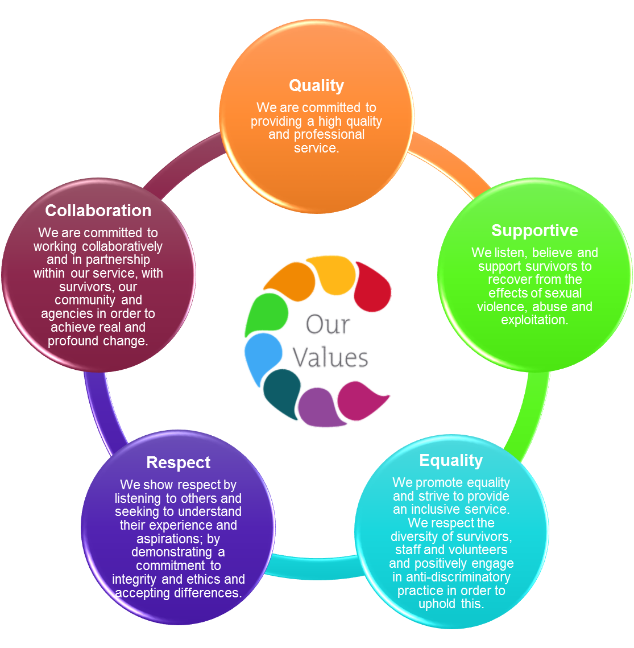
We are a feminist organisation which means we recognise that all forms of rape, sexual abuse and exploitation are acts of violence, that disproportionately affects women and children, involving the abuse of power and control, are a breach of human rights and are fundamentally rooted in gender inequality.

Our Strategic Priorities

ADVICE ON COMPLETING YOUR APPLICATION FORM

As part of WRASAC’s commitment to equal opportunities, candidates for each post are treated equally. Application forms are the only basis on which the first selection is made to decide whom to call for interview. Therefore only information, which appears on the form (and continuation pages), can be considered. It is very important that your completed form contains both the information we want about your skills and experience and the information you want to give us. These advice notes are intended to help you to complete your form effectively.

1 Read all the information provided especially the job description and person specification. These outline the duties you would be expected to carry out in this post and lists the skills, knowledge and abilities that the short listing/interview panel will be looking for.

2 Section 4 asks you to note down your general experience and is the most important part of your application. This is your chance to explain why you are suitable for the job. It is not enough to say you have the experience – you must demonstrate experience and skills with specific examples. Relevant experience may be from your current or previous jobs or from out with formal employment.

3 We have lots of information about our service on our website www.wrasac.org.uk.

4 Do not send your CV in addition to or in place of a completed application form as it will not be considered by the short-listing panel.

5 A Protection of Vulnerable Groups and Non Police Personnel Vetting is required as part of the job.

6 Completing the Equal Opportunities Monitoring Form is voluntary but the information requested here is useful as it allows us to monitor the effectiveness of our policy of equal opportunities in employment.

7 All applicants must complete all parts of the application form.

8 Application forms must arrive on time forms arriving late will not be considered.

9 References are normally taken up for the short listed applicants before interview. If you do not wish one or all references to be taken up at that point please indicate on the relevant page. It is our policy not to make a job offer without taking up references.

Job Description & Person Specification

Job Title: Access and Inclusion Worker

JOB PURPOSE: Improve access to support for survivors of sexual violence and their supporters by engaging and collaborating with survivors to identify and address their needs.

RESPONSIBLE TO: Deputy Manager

Salary: £25,370 per annum (pro rata)
Hours: 28 hours per week (FT hours are 35)
Probation: This post is subject to 12 month probationary period if offer of permanent position is made.
Location: Dundee & Angus
Holidays: 33 Days plus 5 Public Holidays (pro rata)
Pension: Employer contribution at 6% to CIS pension fund.

Summary of main responsibilities and activities
Service Outcomes
- Improve access to support for survivors of sexual violence and their supporters.
- Proactively work to identify and overcome barriers to support.
- Engage and collaborate with survivors to identify and address their needs.

MAIN DUTIES

- Support survivors with the effects of trauma associated with sexual violence and abuse through group work and 1:1 support
- To contribute to the development of new support services within the Centre where appropriate.
- To develop, co-ordinate, facilitate and evaluate group work programme’s for survivors who are on our waiting list for therapeutic support and post support for survivors
- To develop, co-ordinate and facilitate a WRASAC Service User Forum
- Develop opportunities for volunteers within WRASAC
- Co-facilitate Volunteer and Staff Induction training with staff within WRASAC and other centres within the Rape Crisis Network
- To co-facilitate the delivery of volunteer training and that of multi-agency and community groups as required.
- Provide Introductory Meetings to survivors when required
- Assist WRASAC in production of quality monitoring and evaluation
- Develop materials and resources for service users, volunteers and agencies.
- Provide support and guidance to WRASAC volunteers and placement students and/or mentoring to WRASAC workers undertaking qualifications.
- Ensure high quality record of work with survivors on our online Case Management System – OASIS.
- Establish and maintain effective working relationships with staff from other agencies to ensure holistic needs of survivors are met.

- Represent WRASAC on relevant bodies.
- Assist in awareness raising of issues around rape sexual abuse and exploitation through training, promotional events, talks etc.
- To regularly liaise with the team to monitor and assess current provision, identify gaps and develop service provision to more effectively meet the needs of women/young women.
- Model a resilient approach to working in the service demonstrating the importance of self-care and boundary setting.
- Use appropriate workload management techniques.

GENERAL TASKS

- Liaise with WRASAC Manager and Board of Governors as required and contribute positively to the overall work and aims of WRASAC
- Attend individual supervision, team meetings and practice development meetings along with any other trainings, conferences and seminars where appropriate.
- To work in a way that reflects the culture and values of WRASAC where quality, support, equality, respect and collaboration are recognised as valued and important.
- Assist with development of WRASAC policies and procedures.
- Prepare relevant reports and papers as required.
- To ensure that the development and delivery of support recognises the additional barriers and inequalities faced by survivors of sexual violence from marginalized groups and communities and strives to promote at all times inclusive and anti-discriminatory practice across all aspects of the service.
- To work in accordance with WRASAC’s policy on Equal Opportunities.
- To work as part of a team
- To communicate effectively (written, electronic and verbal)
- Flexibility of working hours. This post will involve some evening and weekend work.
- Any other duties as required.

OTHER DUTIES

This job description is a broad picture of the post at the date of preparation. It is not an exhaustive list of all possible duties and it is recognised that jobs change and evolve over time. Consequently, this is not a contractual document and the post holder will be required to carry out any other duties to the equivalent level that are necessary to fulfil the purpose of the job.

PERSON SPECIFICATION

 | ESSENTIAL REQUIREMENTS | DESIRABLE REQUIREMENTS | METHOD OF ASSESSMENT
Professional / Educational Qualifications | Experience of working directly with people affected by sexual violence and/or gender-based violence | HND level or above in Social Care, Community Education or similar discipline.  COSCA Counselling Skills Certificate or similar  Degree in relevant area | Certificates  Application
Relevant work / other experience | Experience of working with women with mental health issues or complex support needs  Experience of developing, and delivering group-work to survivors  Experience of developing, delivering and evaluating training  Experience of writing reports.  Experience of networking and liaising with agencies and other groups.  Experience of responding to disclosures.  Experience of maintaining professional boundaries  Experience of service user involvement/participation  Experience of child protection and vulnerable adult protection guidelines and legislation  Experience working effectively as part of a team | Significant experience in providing trauma based models of support to survivors using counselling skills (at least one year).  Experience of recruiting, training, managing and supervising volunteers | Application  Interview  References
Skills & Knowledge | Clearly articulates an understanding and commitment to a feminist analysis of gender based violence.  Knowledge of the impact of rape and sexual abuse on survivors.  Understanding the range of methods and tools to support women.  Good planning, organisational and prioritisation skills.  Excellent inter-personal and communication skills  Skilled in use of IT for self-administration e.g., Microsoft, excel, email and internet.  Capable of using own initiative and of meeting tight deadlines | Knowledge and understanding of issues for voluntary sector.  Ability to communicate confidently and persuasively with a variety of groups, organisations and agencies.  Knowledge of current legislation, policy and strategy relating to the violence against women agenda  Thorough knowledge of issues relating to sexual violence | Application  Interview  References
Personal Qualities | A commitment to the values and work of WRASAC.  Demonstrates a resilient approach to the workplace and has clear strategies for managing self.  Evidence of a ‘can-do’ attitude, with the ability and willingness to problem solve, involving others when necessary.  High level of personal commitment to promoting equality and diversity. |  | Application  Interview  References
Additional Job Requirements | Member of PVG Scheme or willingness to become a member of the PVG Scheme with satisfactory scheme record and/or scheme record update.  Must be able to work flexibly (including evenings and weekends) to meet the needs of WRASAC. | Full Drivers licence and access to a car. | Application  Interview

