Recruitment Pack

Advocacy and Support Worker
Business: 01382 205556
Support: 01382 201291
info@wrasac.org.uk
support@wrasac.org.uk
www.wrasac.org.uk

Dear Applicant

Thank you for your interest in applying for a post with Women’s Rape and Sexual Abuse Centre. Please find enclosed the following documents:-

- Advice on completing your application form
- Information about WRASAC
- Job Description and Person Specification

Please do not send a curriculum vitae as this will not be considered.

Please note, all applications and relevant recruitment documents will be held confidentially and destroyed after 6 months, apart from documents relating to the successful applicant.

Your completed application should be submitted via email by sending it to recruitment@wrasac.org.uk.

Closing Date is Sunday 19th June 2022 at midnight

Interviews will be held Week commencing 27th June 2022

Please note this post is 28 hours per week and is temporary for a period of 12 months to cover maternity leave.

We would appreciate it if you would take the time to complete this equal opportunities survey: Click Here

We look forward to receiving your completed application form.

Yours sincerely

Kristina Piggott
Deputy Manager

Sangobeg House, 4 Francis Street, Dundee, DD3 8HH
WRASAC Dundee & Angus is a company limited by guarantee, registered with OSCR and registered in Scotland as company number SC241372 and charity number SC009070.
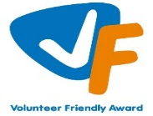
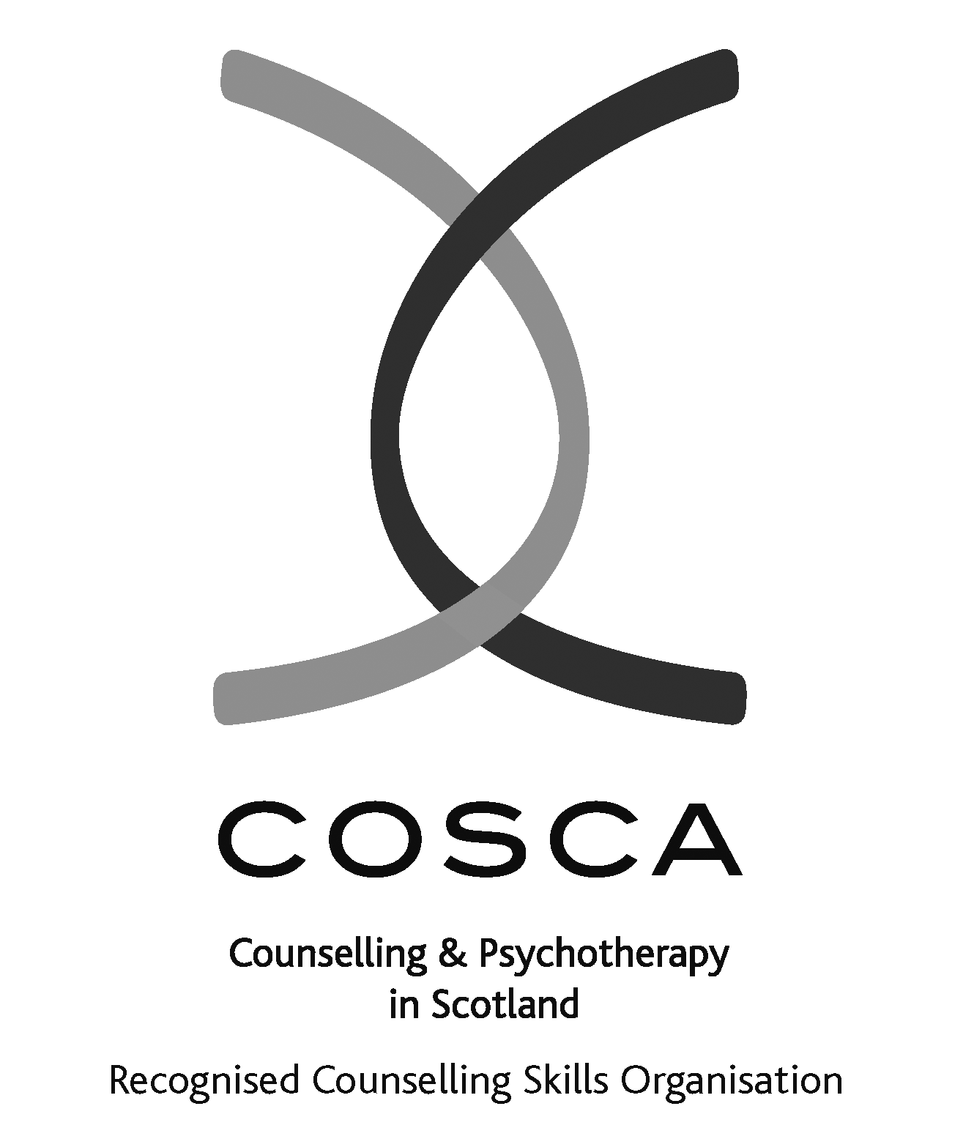

About our service

The Women’s Rape and Sexual Abuse Centre – Dundee and Angus (WRASAC) has been supporting survivors of rape, sexual abuse and exploitation and raising awareness about the damaging effects of sexual violence since 1984. We are a registered charity and a company limited by guarantee.

WRASAC has a dynamic team of 29 staff members.
We provide a range of services to survivors of sexual violence, abuse and exploitation including:
Advocacy
Works with survivors who are thinking about or are engaging with the Criminal Justice System. This includes support to report to the police, with court appearances, accessing the Sexual Assault and Referral Network (forensic examination for those not wishing to report in immediate aftermath of a sexual assault) and supports them with any civil protective orders.
Women’s Support Service
Provides trauma informed support to survivors in a one to one and group setting. We offer emotional and practical support on a one to one basis, by telephone, video call, letter, email, or group work.
Women are empowered to speak about their abuse in a safe, confidential environment. We provide structured support groups, a creative group, and telephone and crisis support. We also offer a complimentary therapy service to women engaging in the service.
Additionally, we have an Outreach Support Service that operates in Rural Angus.
WRASAC also works in a variety of ways to improve service provision to all survivors regardless of where they may present for support. We participate in many partnerships across Dundee and Angus, Scotland and even across Europe.
Most importantly, though, we are in the business of working within our communities to change attitudes so we can, in the longer term, prevent and reduce sexual violence from happening in the first place.
Dundee and Angus Young Survivors (DAYS)
This service offers confidential and professional, emotional and practical support to all young survivors - of all gender identities - aged from 8 to 18; who have experienced sexual violence at any time; and who live in Dundee or Angus.
Vice Versa
Offers support and advocacy to women involved in prostitution and commercial sexual exploitation.
Prevention Work
We have a dedicated Prevention Worker who works in schools, colleges and youth settings in Dundee and Angus delivering the Rape Crisis Scotland Prevention Pack.
Training and Awareness Raising
We provide a monthly Information Session to staff from Dundee and Angus. We also provide training on a range of topics including, dealing with disclosures, understanding sexual violence and dealing with trauma. Additionally we run community awareness raising events, like our Reclaim the Night march each year.

Vision, Values and Strategic Priorities
In 2017-18, after a long period of reviewing and consulting with staff, volunteers, trustees, survivors and partner agencies we developed our new Strategic Plan and updated our Vision, Mission Statement and Values.

Our Vision
For a world free from sexual violence, abuse and exploitation and a society in which everyone has equality, freedom and choices to live the lives they want and thrive.

Our Mission
To support survivors who have experienced any form of sexual violence, abuse or exploitation in their lives.
To promote equality and raise public awareness of the routes of sexual violence and its damaging and life-changing effects.

Our Values
We believe first and foremost that perpetrators of rape, sexual abuse and exploitation are responsible for their actions – not survivors.

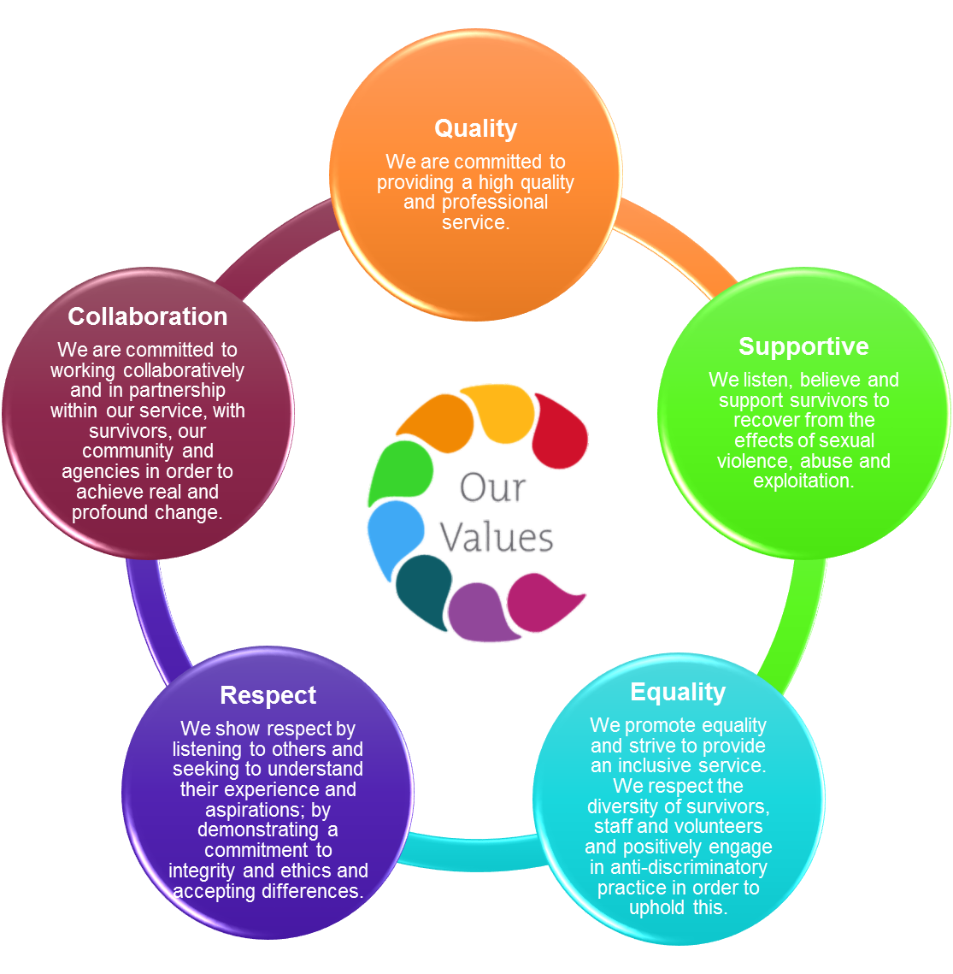
We are a feminist organisation which means we recognise that all forms of rape, sexual abuse and exploitation are acts of violence, that disproportionately affects women and children, involving the abuse of power and control, are a breach of human rights and are fundamentally rooted in gender inequality.

Our Strategic Priorities

ADVICE ON COMPLETING YOUR APPLICATION FORM

As part of WRASAC’s commitment to equal opportunities, candidates for each post are treated equally. Application forms are the only basis on which the first selection is made to decide whom to call for interview. Therefore only information, which appears on the form (and continuation pages), can be considered. It is very important that your completed form contains both the information we want about your skills and experience and the information you want to give us. These advice notes are intended to help you to complete your form effectively.

1 Read all the information provided especially the job description and person specification. These outline the duties you would be expected to carry out in this post and lists the skills, knowledge and abilities that the short listing/interview panel will be looking for.

2 Section 4 asks you to note down your general experience and is the most important part of your application. This is your chance to explain why you are suitable for the job. It is not enough to say you have the experience – you must demonstrate experience and skills with specific examples. Relevant experience may be from your current or previous jobs or from out with formal employment.

3 We have lots of information about our service on our website www.wrasac.org.uk.

4 Do not send your CV in addition to or in place of a completed application form as it will not be considered by the short-listing panel.

5 A Protection of Vulnerable Groups and Non Police Personnel Vetting is required as part of the job.

6 Completing the Equal Opportunities Monitoring Form is voluntary but the information requested here is useful as it allows us to monitor the effectiveness of our policy of equal opportunities in employment.

7 All applicants must complete all parts of the application form.

8 Application forms must arrive on time forms arriving late will not be considered.

9 References are normally taken up for the short listed applicants before interview. If you do not wish one or all references to be taken up at that point please indicate on the relevant page. It is our policy not to make a job offer without taking up references.

Background Information for The National Advocacy Project

The National Advocacy Project is funded by the Scottish Government and is a partnership between RCS and local Rape Crisis Centers across Scotland. The project aims to provide support and advocacy to survivors who have engaged or are considering engaging with the criminal justice system following a sexual crime.

Rape Crisis Scotland is a national charity working to end sexual violence.

Rape Crisis Scotland’s aims are to:

Challenge prejudicial attitudes towards survivors of sexual violence;

Work with local Rape Crisis Centers to ensure survivors are offered consistent, high quality support;

Provide a National Helpline to offer support to survivors of sexual violence across Scotland;

Assist in the development of new rape crisis provision around Scotland; and

Provide a central information and resource service on sexual violence.

Rape Crisis Scotland has 17 member rape crisis centres across Scotland. Womens Rape and Sexual Abuse Centre Dundee and Angus is based in Dundee, with possible outreach in Dundee and Angus. The post will require travel to courts in the Central Belt.

The broad objectives of the project are:
- An improvement in the support available to survivors of rape and serious sexual crime
- An improvement in the experience of the criminal justice process for survivors of rape and serious sexual crime
- The development of a better understanding of motivations whether or not to proceed within the criminal justice process, and what difference advocacy support makes to this decision.

.

This post is funded by the Scottish Government until March 2022. Subject to additional funding, the post will continue to March 2023.

Female applicants only under Schedule 9, Part 1 of the Equality Act 2010

Job Description & Person Specification

Job Title: Advocacy and Support Worker

JOB PURPOSE: The overall aim of this post is to provide support and advocacy to survivors who are engaged, or considering engaging, with the criminal justice system following an experience of sexual violence. This role includes supporting survivors to give statements to police and taking on the role of court supporter which can be any Sherriff and High Court within Scotland.

RESPONSIBLE TO: Deputy Manager

Salary: £21,905 rising to £23. 572 after one year in post
Hours: 28 hours per week this is a 12 month temporary post to cover maternity leave
Probation: This post is subject to 6 month probationary period
Location: Dundee & Angus
Holidays: 33 Days, including 5 Public Holidays (pro rata)
Pension: Employer contribution at 6% to CIS pension fund.

MAIN DUTIES

Summary of main responsibilities and activities – National Advocacy Project
- Provide a support and advocacy service to survivors of sexual violence engaging, or considering engaging, with the criminal justice system following an experience of sexual violence.
- Provide emotional and practical support to survivors of sexual violence whose cases do not proceed to court, including access to follow on services. This can be 1:1 sessions either face to face, online and/or by phone.
- Attend and support survivors attending court to give evidence. This can be at any court within the Scotland area. You will be an In Court Supporter for survivors on these occasions.
- Support survivors to give police statements as and when required
- Develop and ensure the effective implementation of relevant referral processes to ensure survivors of sexual violence have enhanced access to support and advocacy services throughout their involvement in the criminal justice process.
- Work in partnership with relevant agencies to enhance responses to survivors of sexual crimes, including, where appropriate, the development and delivery of training inputs.
- Publicise the service offered through the advocacy service, to enhance access to the service across voluntary and public sector agencies.
- Contribute to the development of national policy and strategic work around the criminal justice system and sexual offences through attendance at national advocacy project meetings and provision of information and feedback to the Rape Crisis Scotland National Coordinator.
- Contribute to monitoring and evaluation frameworks to evidence the impact of the advocacy service for survivors of sexual violence and for partner agencies; including production of statistical data and participation in any evaluations which may be commissioned.
- Attend training and deliver training to internally and to external agencies as and when required
- Participate in regular support and supervision sessions.
- Participate in team meetings and peer support sessions
- Provide support and guidance to WRASAC volunteers and placement students and/or mentoring to WRASAC workers undertaking qualifications.
- Assist in awareness raising of issues around rape sexual abuse and exploitation through training, promotional events, talks etc.
- Ensure high quality record of work with survivors on our online Case Management System – OASIS. All notes must be recorded within 72 hours or immediately if there is Child or Adult Protection concerns.
- Must be competent in using
- Model a resilient approach to working in the service demonstrating the importance of self-care and boundary setting.
- Use appropriate workload management techniques.
- To embrace a trauma informed approach when supporting women and children.
- To ensure women and children’s (if applicable) needs are fully assessed and individually tailored support and safety plans are in place and appropriate referrals are made as and when required.
- To provide targeted interventions and information to women, building strong and trusted relationships.
- To provide 1:1 support to enable survivors to understand the impact of sexual abuse
- Any other duties that are relevant to the post and agreed with the Deputy Manager.
- Travel throughout the Scotland area is required for this role

Centre specific duties
- Contribute to the learning and development of staff and volunteers within the Centre in relation to support and advocacy practice and the criminal justice processes.
- Contribute to the running of the Centre including responding to centre enquiries, assisting with general upkeep of the centre property, offering support cover during staff absence and other agreed duties
- Any other duties as required by the post.

OTHER DUTIES
This job description is a broad picture of the post at the date of preparation. It is not an exhaustive list of all possible duties and it is recognised that jobs change and evolve over time. Consequently, this is not a contractual document and the post holder will be required to carry out any other duties to the equivalent level that are necessary to fulfil the purpose of the job.

Please note only women need apply under Schedule 9, Part 1 of the Equality Act 2010.
PERSON SPECIFICATION

 | ESSENTIAL REQUIREMENTS | DESIRABLE REQUIREMENTS | METHOD OF ASSESSMENT
Professional / Educational Qualifications |  | COSCA Certificate in Counselling Skills or a willingness to work towards it. | Certificates  Application
Relevant work / other experience | Experience of providing advocacy, crisis, emotional and practical support and information.  Experience of working with people affected by rape or sexual abuse.  1 years’ experience of working directly with survivors of gender based violence.  Experience of writing reports.  Experience of networking and liaising with agencies and other groups.  Experience of developing, delivering and evaluating training. | Monitoring, data analysis, and evaluation skills. | Application  Interview  References
Skills & Knowledge | Clearly articulates an understanding and commitment to a feminist analysis of gender based violence.  Knowledge of the impact of rape and sexual abuse on survivors.  Some knowledge of Scottish legislation, policy, and government strategy in relation to rape and sexual violence.  Understanding the range of methods and tools to support women.  Good planning, organisational and prioritisation skills.  Excellent organisational skills and ability to manage own workload  Excellent communication skills  Excellent inter-personal and communication skills  Knowledge of adult and child protection policies and procedure  Good IT Skills including being proficient in the use of Microsoft Office | Knowledge and understanding of issues for voluntary sector.  Understanding of the factors that may help or hinder reporting or disclosure of sexual violence.  Understanding of independent advocacy principles. | Application  Interview  References
Personal Qualities | A commitment to the values and work of WRASAC.  Demonstrates a resilient approach to the workplace and has clear strategies for managing self.  Evidence of a ‘can-do’ attitude, with the ability and willingness to problem solve, involving others when necessary.  High level of personal commitment to promoting equality and diversity.  Ability to be flexible and respond to crises in a calm and reassuring manner  Strong team player, committed to an ethos of continuous professional improvement  Committed to a trauma informed approach  Empathic and compassionate |  | Application  Interview  References
Additional Job Requirements | Member of PVG Scheme or willingness to become a member of the PVG Scheme with satisfactory scheme record and/or scheme record update.  Must be able to work flexibly (including evenings and weekends) to meet the needs of WRASAC.  Must be able to work remotely with access to high speed internet.  Ability to meet the travel requirements of the post. | Full Drivers licence and access to a car. | Application  Interview

Women’s Rape and Sexual Abuse Centre Dundee

Post Applied For:

PERSONAL INFORMATION
(Confidential, the top 3 sheets will be removed and not used for short listing purposes)

1. Personal Details

First Names | Surname
Address  Post Code | Telephone Numbers  Work  Home  Mobile  Email

2. References
Please provide details of a minimum of two referees, one of which must be your most recent employer, one of which must be able to comment on your ability to conduct a research project, and one of which must be able to comment on your ability to engage with vulnerable young people.

Name: Contact prior to interview: Y / N

Address:

Email address:
Telephone number:

Relationship to you:

Name: Contact prior to interview: Y / N

Address:

Email address:
Telephone number:

Relationship to you:
- Period of notice required by current employer?

- Are there any dates when you will be unavailable for interview?

- Are there any adjustments that WRASAC will need to make, should you be invited to interview? Please state what these are.

- Are there any restrictions to your residence in the UK, which might affect your right to take up employment? Yes/No

If Yes, please provide details

- If you are successful in your application will you require a work permit prior to taking up employment? Yes/No

Data Protection Statement
The information that you provide on this form and that obtained from other relevant sources will be used to process your application for employment.

The personal information that you give us will also be used in a confidential manner to help us monitor our recruitment process. If you succeed in your application and take up employment with us, the information will be used in the administration of your employment with us and to provide you with information about us or third party via your payslip. We may also use the information if there is a complaint or legal challenge relevant to this recruitment process.

We may check the information collected, with third parties or with other information held by us. We may also use or pass to certain third parties information to prevent or detect crime, to protect public funds, or in other ways as permitted by law.

By signing the application form we will be assuming that you agree to the processing of sensitive personal data, (as described above), in accordance with our registration with the General Data Protection Regulations.

DECLARATION
I declare that to the best of my knowledge and belief the information given is correct and complete. I understand that WRASAC reserves the right to withdraw the offer of employment or to terminate employment already commenced if the information given to us is inaccurate or misleading in any way. Any job offer is conditional upon receipt of satisfactory references and, if required by WRASAC, any medical reports or disclosure check.

Signed __________________________________________ Date _________________

WRASAC is an Equal Opportunities Employer

Applicant No: _________ (office use only)

- Work Experience – Starting with most recent employer
Please continue on additional sheets if necessary.

Post:
Employer/Organisation:
Address:
From: To:
Main Duties:

Reason for leaving:

Post:
Employer/Organisation:
Address:
From: To:
Main Duties:

Reason for leaving:

Employment Continued

Dates from to | Employers name and address | Post title, responsibilities, experience gained, key achievements | Reason for Leaving, Salary

- Membership of professional bodies

3. Educational, Technical & Professional Qualifications

Institute | Qualification gained | Date Achieved

- WRASAC is a feminist organisation, reflecting on our Vision, Mission and Values, how would you feel about working with the organisation?

- Skills, experience and knowledge (please ensure you meet the essential criteria in the person specification maximum and use no more than 2 full A4 pages)

THANK YOU FOR TAKING THE TIME TO COMPLETE THIS FORM
Your completed application should be sent to recruitment@wrasac.org.uk

