Deputy Manager
Business: 01382 205556
Support: 01382 201291
info@wrasac.org.uk
support@wrasac.org.uk
www.wrasac.org.uk

Dear Applicant

Thank you for your interest in applying for a post with Women’s Rape and Sexual Abuse Centre. Please find enclosed the following documents: -

- Advice on completing your application form
- Information about WRASAC
- Job Description and Person Specification

Please do not send a curriculum vitae as this will not be considered.

Please note, all applications and relevant recruitment documents will be held confidentially and destroyed after 6 months, apart from documents relating to the successful applicant.

Your completed application should be submitted via email by sending it to recruitment@wrasac.org.uk.

Closing Date is Wednesday 1st December 2021 at 12pm

Invites to interview will go out Monday 6th December 2021

Interviews will be held on Monday 13th December 2021 via zoom.

Please note this post is 35 Hours per week permanent

We look forward to receiving your completed application form. Enquiries about this position are welcome by phoning or emailing recruitment@wrasac.org.uk.
Yours sincerely

Katie Hardy-Jensen
Manager

Sangobeg House, 4 Francis Street, Dundee, DD3 8HH
WRASAC Dundee & Angus is a company limited by guarantee, registered with OSCR and registered in Scotland as company number SC241372 and charity number SC009070.
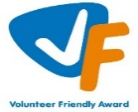

About our service

The Women’s Rape and Sexual Abuse Centre – Dundee and Angus (WRASAC) has been supporting survivors of rape, sexual abuse and exploitation and raising awareness about the damaging effects of sexual violence since 1984. We are a registered charity and a company limited by guarantee.
WRASAC has a dynamic team of 23 staff members, 8 volunteers and an annual income of now just over £750,000 per year.
We provide a range of services to survivors of sexual violence, abuse and exploitation including:
Women’s Support Service
Provides trauma informed support to survivors in a one to one and group setting. We offer emotional and practical support on a one-to-one basis, by telephone, letter, email, or group work.
Women are empowered to speak about their abuse in a safe, confidential environment. We provide structured support groups, a creative group, and telephone and crisis support. We also offer a complimentary therapy service to women engaging in the service.
WRASAC also works in a variety of ways to improve service provision to all survivors regardless of where they may present for support. We participate in many partnerships across Dundee and Angus, Scotland and even across Europe.
Most importantly, though, we are in the business of working within our communities to change attitudes so we can, in the longer term, prevent and reduce sexual violence from happening in the first place.
Advocacy
Works with survivors who are thinking about or are engaging with the Criminal Justice System. This includes support to report to the police, with court appearances, accessing the Sexual Assault and Referral Network (forensic examination for those not wishing to report in immediate aftermath of a sexual assault) and supports them with any civil protective orders.
Dundee and Angus Young Survivors (DAYS)
This service offers confidential and professional, emotional and practical support to all young survivors - of all gender identities - aged from 11 to 18; who have experienced sexual violence at any time; and who live in Dundee or Angus.
Vice Versa
Offers support and advocacy to women involved in prostitution and commercial sexual exploitation.
Prevention Work
We have a dedicated Prevention Worker who works in schools, colleges and youth settings in Dundee and Angus delivering the Rape Crisis Scotland Prevention Pack.
Training and Awareness Raising
We provide a monthly Information Session to staff from Dundee and Angus. We also provide training on a range of topics including, dealing with disclosures, understanding sexual violence and dealing with trauma. Additionally, we run community awareness raising events, like our Reclaim the Night March each year.

Vision, Values and Strategic Priorities
In 2017-18, after a long period of reviewing and consulting with staff, volunteers, trustees, survivors and partner agencies we developed our new Strategic Plan and updated our Vision, Mission Statement and Values.

Our Vision
For a world free from sexual violence, abuse and exploitation and a society in which everyone has equality, freedom and choices to live the lives they want and thrive.

Our Mission
To support survivors who have experienced any form of sexual violence, abuse or exploitation in their lives.
To promote equality and raise public awareness of the routes of sexual violence and its damaging and life-changing effects.

Our Values
We believe first and foremost that perpetrators of rape, sexual abuse and exploitation are responsible for their actions – not survivors.
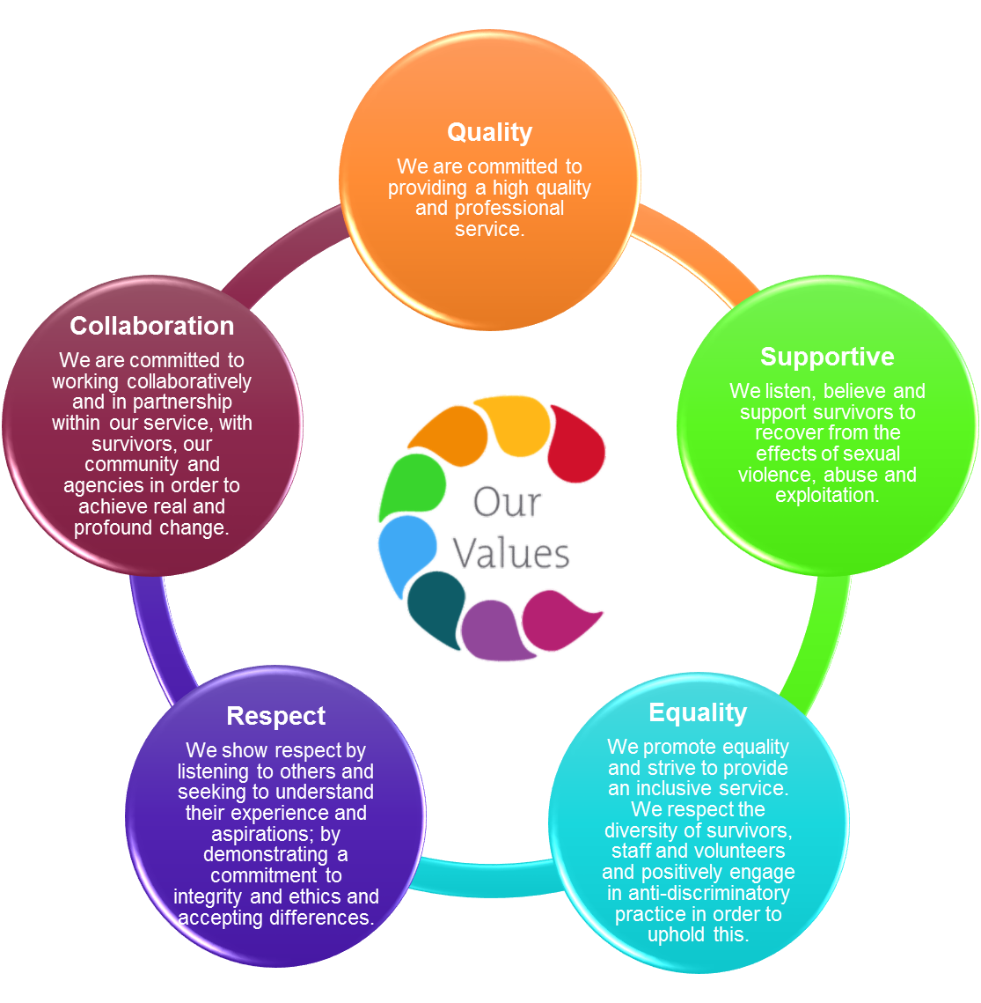
We are a feminist organisation which means we recognise that all forms of rape, sexual abuse and exploitation are acts of violence, that disproportionately affects women and children, involving the abuse of power and control, are a breach of human rights and are fundamentally rooted in gender inequality.

Our Strategic Priorities

ADVICE ON COMPLETING YOUR APPLICATION FORM

As part of WRASAC’s commitment to equal opportunities, candidates for each post are treated equally. Application forms are the only basis on which the first selection is made to decide whom to call for interview. Therefore, only information, which appears on the form (and continuation pages), can be considered. It is very important that your completed form contains both the information we want about your skills and experience and the information you want to give us. These advice notes are intended to help you to complete your form effectively.

1 Read all the information provided especially the job description and person specification. These outline the duties you would be expected to carry out in this post and lists the skills, knowledge and abilities that the short listing/interview panel will be looking for.

2 Section 4 asks you to note down your general experience and is the most important part of your application. This is your chance to explain why you are suitable for the job. It is not enough to say you have the experience – you must demonstrate experience and skills with specific examples. Relevant experience may be from your current or previous jobs or from out with formal employment.

3 We have lots of information about our service on our website www.wrasac.org.uk.

4 Do not send your CV in addition to or in place of a completed application form as it will not be considered by the short-listing panel.

5 A Protection of Vulnerable Groups and Non-Police Personnel Vetting is required as part of the job.

6 Completing the Equal Opportunities Monitoring Form is voluntary, but the information requested here is useful as it allows us to monitor the effectiveness of our policy of equal opportunities in employment.

7 All applicants must complete all parts of the application form.

8 Application forms must arrive on time forms arriving late will not be considered.

9 References are normally taken up for the short-listed applicants before interview. If you do not wish one or all references to be taken up at that point please indicate on the relevant page. It is our policy not to make a job offer without taking up references.

Job Description & Person
Specification
Job Title: Deputy Manager

JOB PURPOSE: To take the lead on ensuring the day to day delivery of services to women, children and young people affected by rape, sexual abuse and sexual exploitation, ensuring that services are delivered to an acceptable standard. Ensure that services are monitored and evaluated and that services are developed to ensure WRASAC are providing consistent, effective and responsive services to women, children and young people.
.
Responsible to: Manager of WRASAC
Salary: £35,672 moving to £36,418 after successful completion of probationary period
Hours: 35 hours per week
Location: Dundee
Holiday Entitlement: 33 Days plus 5 Public Holidays (rising to 36 Days after 3 years’
service)
Pension: Employer contribution at 6% to pension fund.

MAIN DUTIES

- Take responsibility for the overall operational performance and practice of the organisation.
- Provide leadership to staff, with direct line management responsibility for the WSS Team Leader and other operational teams.
- Oversee quality assurance; lead on service development and reviews and ensure the ongoing development, implementation and monitoring of operational plans. In conjunction with seniors ensure service delivery complies with all regulatory and legislative requirements.
- Provide support and supervision, coaching and mentoring services to direct reports.

- Implement effective HR policies and procedures, ensuring the continuous review and development of workplace practices. Support team members with staff management issues, ensuring all legislative and good practice requirements are followed.

- Ensure that WRASAC meet the requirements placed on the organisation by funders and provide reports back to funders as required
- Take overall responsibility for promoting integrated service delivery and a culture of continuous improvement, strong service user focus and collaborative working. Promote effective team communication, team building and planning through collaborative and participatory work practices
- Ensure evaluation and quality assurance of the service is carried out and that service user involvement activities are built into service delivery.
- Act as named lead for child protection and adult support and protection
- Oversee the investigation, reporting and management of incidents, accidents and complaints, ensuring all necessary inspections are undertaken and prepare relevant reports and recommendations.
- Work in partnership with the Manager and Team Leader for Women’s Support Service, to ensure compliance with policies and procedures and all WRASAC property.
- Take responsibility, in partnership with the Manager, for identifying gaps in provision and areas for growth and development of services. Contribute to the strategic planning of services and the development of funding.
- Ensure quantitative and qualitative information on service provision and related issues is collected, analysed and reviewed regularly. Produce written reports, as required. Ensure required audits are completed and monitoring and reporting documents are completed accurately and on time, including developing quality assurance systems and audit tools for the organisation.
- Take a proactive role in promoting equality and anti-discriminatory practice throughout all aspects of the work.
- Perform other duties as reasonably required by the Manager and show commitment to ongoing personal and professional development.

This job description is a broad picture of the post at the date of preparation. It is not an exhaustive list of all possible duties and it is recognised that jobs change and evolve over time.

Consequently, this is not a contractual document and the post holder will be required to carry out any other duties to the equivalent level that are necessary to fulfil the purpose of the job.

PERSON SPECIFICATION

 | ESSENTIAL REQUIREMENTS | DESIRABLE REQUIREMENTS | METHOD OF ASSESSMENT
Professional / Educational Qualifications | Relevant qualification in supporting survivors, for example, COSCA Counselling Skills at least 3 years’ experience in providing trauma based models of support.  Management / Leadership qualification | Diploma in Counselling or equivalent  Qualification in Human Resource Management | Certificates Application
Relevant work / other experience | Experience of working within the violence against women field  At least 2 years’ direct experience of managing staff in formal and informal settings, across multiple teams/services.  Experience of working in/managing direct support services  Experience of identifying gaps in service and implementing quality assurance systems  Experience of implementing monitoring and evaluation systems  Experience in writing funding reports  Experience of promoting and sustaining volunteering within an organisation  Experience of developing and communicating policies, processes and procedures  Experience of chairing meetings and/or facilitating working groups | Experience of writing funding applications  Experience of using Digital Technology to enhance organisation and personal performance.  Understanding of project planning and budgeting | Application Interview References
Skills & Knowledge | Knowledge of the impact of rape, sexual abuse and exploitation on survivors.  Excellent track record in delivery of services, ideally in not for profit sector  Clearly articulates an understanding and commitment to a feminist analysis of gender based violence.  Excellent interpersonal skills with a range of people including staff, service users, donors, volunteers and partner organisations  Good planning, organisational and ability to prioritise effectively, balancing potentially competing areas of work  Excellent communication, numeracy, literacy and IT skills  Understanding and knowledge of Child & Adult Protection Legislation.  Competent Microsoft user (Outlook, Excel, PowerPoint and Word). | Knowledge of the national and local strategies on violence against women | Application Interview References
Personal Qualities | An interest in social justice and a genuine desire to support those affected by rape, sexual abuse and / or exploitation.  A commitment to the values and work of WRASAC.  Demonstrates a resilient approach to the workplace and has clear strategies for managing self.  Evidence of a ‘can-do’ attitude, with the ability and willingness to problem solve, involving others when necessary.  High level of personal commitment to equality and diversity, and ability to work with partners and colleagues from a wide range of backgrounds.  Demonstrates a commitment to continuous professional development |  | Application Interview References
Additional Job Requirements | Member of PVG Scheme or willingness to become a member of the PVG Scheme with satisfactory scheme record and/or scheme record update.  Must be able to work flexibly (including evenings and weekends) to meet the needs of WRASAC.  Full Drivers licence and access to a car.  All candidates must have the right to work in the UK  Occupational Requirement under Schedule 9 (part 1) of the Equality Act 2010 applies. Due to contact with service users the post holder must be female in accordance with the Sex Discrimination Act 1975 Part 7 (2) (e). |  | Application Interview  Certificates  References  Documentation

Women’s Rape and Sexual Abuse Centre Dundee

Post Applied For:

PERSONAL INFORMATION
(Confidential, the top 3 sheets will be removed and not used for short listing purposes)

1. Personal Details

First Names | Surname
Address  Post Code | Telephone Numbers  Work  Home  Mobile  Email

2. References
Please provide details of a minimum of two referees, one of which must be your most recent employer, one of which must be able to comment on your ability to conduct a research project, and one of which must be able to comment on your ability to engage with vulnerable young people.

Name: Contact prior to interview: Y / N

Address:

Email address:
Telephone number:

Relationship to you:

Name: Contact prior to interview: Y / N

Address:

Email address:
Telephone number:

Relationship to you:

- Period of notice required by current employer?

- Are there any dates when you will be unavailable for interview?

- Are there any adjustments that WRASAC will need to make, should you be invited to interview? Please state what these are.

- Are there any restrictions to your residence in the UK, which might affect your right to take up employment? Yes/No

If Yes, please provide details

- If you are successful in your application will you require a work permit prior to taking up employment? Yes/No

Data Protection Statement
The information that you provide on this form and that obtained from other relevant sources will be used to process your application for employment.

The personal information that you give us will also be used in a confidential manner to help us monitor our recruitment process. If you succeed in your application and take up employment with us, the information will be used in the administration of your employment with us and to provide you with information about us or third party via your payslip. We may also use the information if there is a complaint or legal challenge relevant to this recruitment process.

We may check the information collected, with third parties or with other information held by us. We may also use or pass to certain third parties information to prevent or detect crime, to protect public funds, or in other ways as permitted by law.

By signing the application form we will be assuming that you agree to the processing of sensitive personal data, (as described above), in accordance with our registration with the General Data Protection Regulations.

DECLARATION
I declare that to the best of my knowledge and belief the information given is correct and complete. I understand that WRASAC reserves the right to withdraw the offer of employment or to terminate employment already commenced if the information given to us is inaccurate or misleading in any way. Any job offer is conditional upon receipt of satisfactory references and, if required by WRASAC, any medical reports or disclosure check.

Signed __________________________________________ Date _________________

WRASAC is an Equal Opportunities Employer

Applicant No: _________ (office use only)

- Work Experience – Starting with most recent employer
Please continue on additional sheets if necessary.

Post:
Employer/Organisation:
Address:
From: To:
Main Duties:

Reason for leaving:

Post:
Employer/Organisation:
Address:
From: To:
Main Duties:

Reason for leaving:

Employment Continued

Dates from to | Employers name and address | Post title, responsibilities, experience gained, key achievements | Reason for Leaving, Salary

- Membership of professional bodies

3. Educational, Technical & Professional Qualifications

Institute | Qualification gained | Date Achieved

- WRASAC is a feminist organisation, reflecting on our Vision, Mission and Values, how would you feel about working with the organisation?

- Skills, experience and knowledge (please ensure you meet the essential criteria in the person specification maximum and use no more than 2 full A4 pages)

THANK YOU FOR TAKING THE TIME TO COMPLETE THIS FORM
Your completed application should be sent to recruitment@wrasac.org.uk

