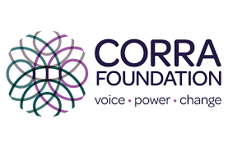



DWH Support & Trauma Job Role

Support: 01382 201291
info@wrasac.org.uk
support@wrasac.org.uk
www.wrasac.org.uk

Dear Applicant

Thank you for your interest in applying for a post with Women’s Rape and Sexual Abuse Centre. Please find enclosed the following documents: -

- Information about Dundee Women’s Hub
- Advice on completing your application form
- Job Description and Person Specification

Please do not send a curriculum vitae as this will not be considered.

Please note, all applications and relevant recruitment documents will be held confidentially and destroyed after 6 months, apart from documents relating to the successful applicant.

Your completed application should be submitted via email by sending it to recruitment@wrasac.org.uk.

Closing Date is Friday 29th May 2026 at 12 noon

Invites to interview will go out Friday 29th May by 5pm

Interviews will be held on Friday 5th June

Please note this post is 25 Hours per week

We look forward to receiving your completed application form. Enquiries about this position are welcome by phoning or emailing recruitment@wrasac.org.uk.

Yours sincerely

Katie Hardy-Jensen
WRASAC CEO

WRASAC, Ground Floor, 4 Chamber of Commerce Buildings, Panmure Street, DD1 1EP
WRASAC Dundee & Angus is a company limited by guarantee, registered with OSCR and registered in Scotland as company number SC241372 and charity number SC009070.

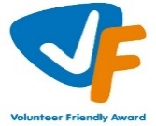
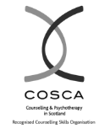

Dundee Womens Hub
WRASAC is the lead organisation for Dundee Women’s Hub, this includes overarching responsibility for policies and procedures. This is supported by the Dundee Women’s Hub Steering Group which includes representation from partner organisations across Dundee.

Dundee Women’s Hub is a multi-agency support hub for women who are experiencing or who have experienced multiple disadvantage, with a particular focus on substance/alcohol use, homelessness, commercial sexual exploitation and other gender based violence.
Dundee Women’s Hub has three main aims:
- To increase the capacity and co-ordination of services to respond to the needs of women experiencing substance use and multiple disadvantage
- To improve access to substance use and related services for women in Dundee
- To improve the physical and emotional wellbeing for women who experience substance use and multiple disadvantage
Dundee Women’s Hub is a safe and non-judgemental space for women to access 1:1 and group support. All services working within Dundee Women’s Hub will offer holistic, trauma-informed support. Services working from Dundee Women’s Hub will offer consistent advocacy on behalf of women to ensure that their voices are heard and needs being met.
Dundee Women’s Hub will adapt and develop based on the voices and experiences of women. We aim to have ongoing and continued input from women with lived/living experience to guide the project.
Vice Versa
Vice Versa provides support to adult women who have been involved, are currently involved or are at risk of being involved in Commercial Sexual Exploitation (CSE). The Vice Versa service is also based within Dundee Women’s Hub as the women we support often experience multiple disadvantage which may include substance use, homelessness, physical and mental health issues, welfare issues and extensive historical and ongoing trauma.
The aim of the project is to provide women with safety and stabilisation support and with all issues that impact on their involvement in CSE. Support can include 1:1 session in the centre or on outreach, supporting to attend appointments and groups, advocacy support and signposting to other organisations or support. Support is led entirely by the women and their needs and priorities.

Information about WRASAC

The Women’s Rape and Sexual Abuse Centre – Dundee and Angus (WRASAC) has been supporting survivors of rape, sexual abuse and exploitation and raising awareness about the damaging effects of sexual violence since 1984. We are a registered charity and a company limited by guarantee.

We provide a range of services to survivors of sexual violence, abuse and exploitation including:
Women’s Support Service including our Initial Referral Team
Dundee and Angus Young Survivors (DAYS)
Justice Advocacy Service
Prevention Work
Gender Based Violence (GBV) Team
Training and Awareness Raising

WRASAC Vision, Values and Strategic Priorities

Our Vision
For a world free from sexual violence, abuse and exploitation and a society in which everyone has equality, freedom and choices to live the lives they want and thrive.

Our Mission
To support survivors who have experienced any form of sexual violence, abuse or exploitation in their lives.
To promote equality and raise public awareness of the routes of sexual violence and its damaging and life-changing effects.

Our Values
We believe first and foremost that perpetrators of rape, sexual abuse and exploitation are responsible for their actions – not survivors.

We are a feminist organisation which means we recognise that all forms of rape, sexual abuse and exploitation are acts of violence, that disproportionately affects women and children, involving the abuse of power and control, are a breach of human rights and are fundamentally rooted in gender inequality.

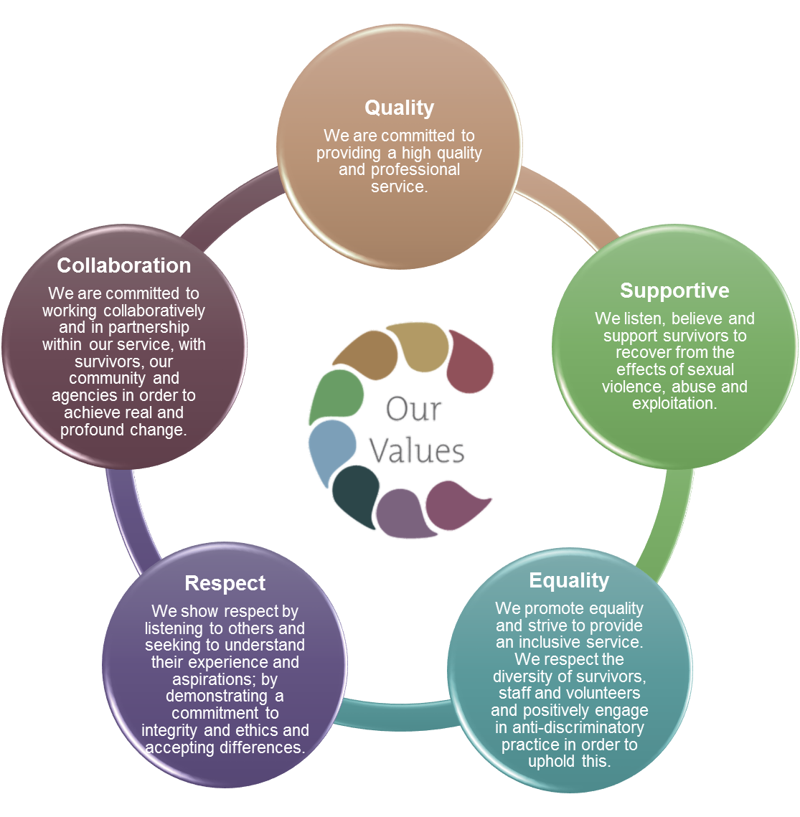

Our Strategic Priorities

ADVICE ON COMPLETING YOUR APPLICATION FORM

As part of our commitment to equal opportunities, candidates for each post are treated equally. Application forms are the only basis on which the first selection is made to decide whom to call for interview. Therefore, only information, which appears on the form (and continuation pages), can be considered. It is very important that your completed form contains both the information we want about your skills and experience and the information you want to give us. These advice notes are intended to help you to complete your form effectively.

1 Read all the information provided especially the job description and person specification. These outline the duties you would be expected to carry out in this post and lists the skills, knowledge and abilities that the short listing/interview panel will be looking for.

2 Section 4 asks you to note down your general experience and is the most important part of your application. This is your chance to explain why you are suitable for the job. It is not enough to say you have the experience – you must demonstrate experience and skills with specific examples. Relevant experience may be from your current or previous jobs or from out with formal employment.

3 We have lots of information about our service on our website www.wrasac.org.uk.

4 Do not send your CV in addition to or in place of a completed application form as it will not be considered by the short-listing panel.

5 A Protection of Vulnerable Groups and Non-Police Personnel Vetting is required as part of the job.

6 Completing the Equal Opportunities Monitoring Form is voluntary, but the information requested here is useful as it allows us to monitor the effectiveness of our policy of equal opportunities in employment.

7 All applicants must complete all parts of the application form.

8 Application forms must arrive on time, forms arriving late will not be considered.

9 References are normally taken up for the short-listed applicants before interview. If you do not wish one or all references to be taken up at that point please indicate on the relevant page. It is our policy not to make a job offer without taking up references.

Job description & Person Specification
Dundee Women’s Hub Support and Trauma Worker

We are looking to recruit a Women's Hub Support and Trauma Worker with the ideal candidate will have significant experience in providing support to people using trauma informed support skills and have a sound knowledge of the impact of rape, sexual abuse and exploitation on survivors.

We offer a competitive salary, excellent terms and conditions and the opportunity to gain invaluable skills and experience.

Dundee Women’s Hub is a multi-agency support hub for women impacted by substance use and multiple disadvantages such as gender-based violence, housing and homelessness, benefits and debt, health and wellbeing, relationships with children and family, and extensive experiences of historical and ongoing trauma.

Dundee Women’s Hub will improve access to substance use and related services for women with the overall goal of improving physical and emotional wellbeing for women and supporting to empower women to make informed choices.

What We Offer:

Salary: £21,762 and after one year probation £23,426
Funder: CORRA
Hours: 25 hours per week- Part time (Funded until September 2027 with possible continuation as per funding)
Location: Dundee Base and Outreach within Dundee area
Annual Leave: 38 days + 5 public holidays per year (FTE), increasing to 42 days + 5 public holidays after 4 years of service. (This will be pro rata based on a 25-hour working week.)
Pension: 6% employer contribution
Supportive & Inclusive Culture: Join a passionate, values-driven team working to create real change for survivors.
RESPONSIBLE TO: DWH Co-Ordinator

Job purpose:
To provide a free and confidential quality support service to women who are impacted by substance use and/or other multiple disadvantage.
Support is led entirely by the women and their needs and priorities. Support will aim to provide women with safety and stabilisation, addressing vulnerabilities and barriers to accessing support and empowering women to make their own informed choices.
Support can include 1:1 sessions within the hub or on outreach, supporting to attend appointments and groups, advocacy support and signposting to other organisations or avenues of support. Support may also include supporting and developing group work or other supportive opportunities and events within Dundee Women’s Hub.

MAIN DUTIES

Support

- To provide 1:1/group support and advocacy to adult women who are impacted by substance use and other forms of multiple disadvantage.
- To provide opportunities to increase safety and choice, and reduce harm in relationship to substance use and multiple disadvantage, by empowering women to make positive and informed decisions.
- Support women with the effects of trauma associated with substance use and multiple disadvantage.
- Establish and maintain effective working relationships with staff from other agencies to ensure holistic needs of women are met.

Awareness Raising
- To raise awareness of women’s experiences and to challenge popular myths and beliefs around the issues which impact women.
- Assist in awareness raising of issues impacting women attending Dundee Women’s Hub through training, promotional events, talks etc.
- Represent Dundee Women’s Hub and WRASAC on relevant bodies.
- Develop materials and resources for service users and agencies.
- To provide support and information to workers from the statutory and voluntary sector who are working with women impacted by substance use and multiple disadvantage.

Evaluation and Monitoring
- Ensure high quality record of work with survivors on our online Case Management System – OASIS.
- Model a resilient approach to working in the service demonstrating the importance of self-care and boundary setting.
- Use appropriate workload management techniques.
- Assist Dundee Women’s Hub/WRASAC in production of quality monitoring and evaluation.

General Tasks
- Liaise with WRASAC Manager and Board of Governors.
- Attend internal and external meetings, trainings, conferences and seminars where appropriate.
- Liaise and undertake joint work with agencies and other groups.
- Assist with development of WRASAC policies and procedures.
- Prepare relevant reports and papers as required.
- Provide support and guidance to volunteers and placement students as required.
- Provide mentoring to WRASAC workers undertaking qualifications.

OTHER DUTIES
This job description is a broad picture of the post at the date of preparation. It is not an exhaustive list of all possible duties and it is recognised that jobs change and evolve over time. Consequently, this is not a contractual document and the post holder will be required to carry out any other duties to the equivalent level that are necessary to fulfil the purpose of the job.

WHY JOIN DWH?
This is an opportunity to be a part of a dedicated organisation and team in making a real difference
for women impacted by substance use and/or other multiple disadvantage. At DWH, we recognise
that supporting others starts with supporting our staff. That’s why we invest in your wellbeing and
professional development through:
- Yearly and quarterly wellbeing days – Time dedicated to rest and self-care, ensuring you can continue your work with resilience.
- Staff development time – Space to reflect, grow, and enhance your skills in a supportive environment.
- Coaching and supervision – Individual and team support to help you thrive in your role.
- Ongoing training – Access to continuous learning opportunities to keep you at the forefront of best practices.
- Staff support- access to occupational health and tailored employee assistance tools

Person Specification

 | ESSENTIAL REQUIREMENTS | DESIRABLE REQUIREMENTS | METHOD OF ASSESSMENT
Professional / Educational Qualifications |  | COSCA Certificate in Counselling Skills or a willingness to work towards it.  Social Work/Community Education degree or equivalent related qualification | Certificates  Application
Relevant work / other experience | Significant experience in providing support to people in crisis (at least one year).  Experience of working with women impacted by substance/alcohol use, gender-based violence, mental health issues, or who have experiences multiple disadvantage  Experience of facilitating group work  Experience of writing reports.  Experience of networking and liaising with agencies and other groups.  Experience of partnership working with external agencies. | Experience of working with women effected by gender-based violence  Experience of developing, delivering and evaluating training. | Application  Interview  References
Skills &Knowledge | Clearly articulates an understanding and commitment to a feminist analysis of supporting women  A clear understanding of harm reduction approach to support  Excellent inter-personal and communication skills  Understanding the range of methods and tools to support women.  Good planning, organisational and prioritisation skills. | Knowledge and understanding of issues for voluntary sector. | Application  Interview  References
Personal Qualities | A commitment to the values and ethos of WRASAC  A self-starter with the ability to organise and prioritise workload to agreed standards.  Ability to manage competing demands and support people in crisis.  Team player and able to use own initiative when necessary.  Evidence of a ‘can-do’ attitude, with the ability and willingness to problem solve, involving others when necessary.  High level of personal commitment to equality and diversity, and ability to work with partners and colleagues from a wide range of backgrounds. |  | Application  Interview  References
Additional Job Requirements | Member of PVG Scheme or willingness to become a member of the PVG Scheme with satisfactory scheme record and/or scheme record update.  Must be able to work flexible (including evenings and weekends) to meet the needs of Dundee Women’s Hub.  Access to vehicle, business insurance and full driving licence (All subject to DVLA checks) |  | Application  Interview

Women’s Rape and Sexual Abuse Centre Dundee

Post Applied For:

1. Personal Details

First Name:

Address:  Post Code: | Contact information:  Mobile:  Email:

2. References
Please provide details of a minimum of two referees, one of which must be your most recent employer.

Name: Contact prior to interview: Y/N

Address:

Email address:
Telephone number:

Relationship to you:

Name: Contact prior to interview: Y/N

Address:

Email address:
Telephone number:

Relationship to you:

- Period of notice required by current employer?

- Are there any dates when you will be unavailable for interview?

- Are there any adjustments that WRASAC will need to make, should you be invited to interview? Please state what these are.

- Are there any restrictions to your residence in the UK, which might affect your right to take up employment? If Yes, please provide details

- If you are successful in your application will you require a work permit prior to taking up employment?

- Do you hold a full drivers licence? Yes/No

- Do you currently have car insurance for business use? Yes/No
If no, then we would need you to get this set up before starting employment if successful.

- Are you related to any employee or board member of WRASAC Dundee and Angus? Yes / No If yes, please provide details:

- Are you or have you ever been a member of WRASAC Dundee and Angus Board of Directors? Yes / No If yes, please provide details:
- Where did you see this vacancy advertised

Data Protection Statement
The information that you provide on this form and that obtained from other relevant sources will be used to process your application for employment.

The personal information that you give us will also be used in a confidential manner to help us monitor our recruitment process. If you succeed in your application and take up employment with us, the information will be used in the administration of your employment with us and to provide you with information about us or third party via your payslip. We may also use the information if there is a complaint or legal challenge relevant to this recruitment process.

We may check the information collected, with third parties or with other information held by us. We may also use or pass to certain third parties information to prevent or detect crime, to protect public funds, or in other ways as permitted by law.

By signing the application form we will be assuming that you agree to the processing of sensitive personal data, (as described above), in accordance with our registration with the Data Protection Commissioner.

DECLARATION
I declare that to the best of my knowledge and belief the information given is correct and complete. I understand that WRASAC reserves the right to withdraw the offer of employment or to terminate employment already commenced if the information given to us is inaccurate or misleading in any way. Any job offer is conditional upon receipt of satisfactory references and, if required by WRASAC, any medical reports or disclosure check.

Signed
Date

WRASAC is an Equal Opportunities Employer

Applicant No: _________ (office use only)

- Work Experience – Starting with most recent employer
Please continue on additional sheets if necessary.

Post:

Address:
From: To:
Main Duties:

Reason for leaving:

Post:
Address:
From: To:
Main Duties:

Reason for leaving:

Employment Continued for the last 5 years minimum (please let us know if you have had any gaps in employment and if so please note why)

Dates from to | Employers name and address | Post title, responsibilities, experience gained, key achievements | Reason for Leaving, Salary

- Membership of professional bodies

3. Educational, Technical & Professional Qualifications

Institute | Qualification gained | Date Achieved

- Skills, experience and knowledge (please refer to the person specification)

Your completed application should be submitted via email by sending it to recruitment@wrasac.org.uk

