Recruitment Pack
Young People’s Support and Trauma Worker
(Part-time)
Business: 01382 205556
Support: 01382 201291
info@wrasac.org.uk
support@wrasac.org.uk
www.wrasac.org.uk

Dear Applicant

Thank you for your interest in applying for a post with Women’s Rape and Sexual Abuse Centre. Please find enclosed the following documents:-

- Advice on completing your application form
- Information about WRASAC
- Job Description and Person Specification

Please do not send a curriculum vitae as this will not be considered.

Please note, all applications and relevant recruitment documents will be held confidentially and destroyed after 6 months, apart from documents relating to the successful applicant.

Your completed application should be submitted via email by sending it to recruitment@wrasac.org.uk.

Salary £25,377.00 (Pro rata) moving to £28,333 after successful completion of probation

Contract and Hours Part Time (14 Hours) Temporary until May 2021

Location Dundee and Angus

Holiday entitlement 33 Days plus 5 Public Holidays pro rata

Pension Employer contribution at 6% to pension fund

Closing date 13th December 2019

Yours sincerely
Heather Williams
Interim Manager

2 Dudhope Street, Dundee, DD1 1JU
WRASAC Dundee & Angus is a company limited by guarantee, registered with OSCR and registered in Scotland as company number SC241372 and charity number SC009070.

Advice on Completing This Application Form
As part of WRASAC’s commitment to equal opportunities, candidates for each post are treated equally. Application forms are the only basis on which the first selection is made to decide whom to call for interview. Therefore only information, which appears on the form (and continuation pages), can be considered. It is very important that your completed form contains both the information we want about your skills and experience and the information you want to give us. These advice notes are intended to help you to complete your form effectively.

1 Read all the information provided especially the job description and person specification. These outline the duties you would be expected to carry out in this post and lists the skills, knowledge and abilities that the short listing/interview panel will be looking for.
2 The application form will be photocopied so that the form should be completed in black ink or typescript.
3 Section 4 asks you to note down your general experience and is the most important part of your application. This is your chance to explain why you are suitable for the job. It is not enough to say you have the experience – you must demonstrate experience and skills with specific examples. Relevant experience may be from your current or previous jobs or from out with formal employment.
4 Should you need to use an additional sheet of paper, please indicate the name of the post on the top of the sheet. Do not send your CV in addition to or in place of a completed application form as it will not be considered by the short-listing panel.
5 A Protection of Vulnerable Groups and Non Police Personnel Vetting is required as part of the job.
6 Completing the Equal Opportunities Monitoring Form is voluntary but the information requested here is useful as it allows us to monitor the effectiveness of our policy of equal opportunities in employment.
7 All applicants must complete all parts of the application form.
9 Application forms must arrive on time forms arriving late will not be considered.
10 References are normally taken up for the short listed applicants before interview. If you do not wish one or all references to be taken up at that point please indicate on the relevant page. It is our policy not to make a job offer without taking up references.
Your Personal Data
WRASAC respects your personal data and undertakes to comply with the Data Protection Act 1998 and General Data Protection Regulations. The personal data you have provided will be used for the purposes of assessing you for the post for which you have applied. Your data may be disclosed to parties involved in the recruitment and selection process. The personal data you have provided on the Equal Opportunities form will be used in statistical form for monitoring equal opportunities, and your data (excluding your name) may be disclosed to parties involved in monitoring the effectiveness of our Equal Opportunities Policy.

About our service
The Women’s Rape and Sexual Abuse Centre (WRASAC) was established in 1984 by Dundee Women’s Aid after they identified a need for a service to provide support to women who had experienced rape or sexual assault.

We offer emotional and practical support on a one to one basis, by telephone, letter, email, drop in and/or group work. Women are empowered to speak about their abuse in a safe, confidential environment. We provide structured support groups, a creative group, a weekly drop-in and telephone helpline. We also offer a complimentary therapy service to women engaging in the service. We have an Outreach Support Service that operates in Rural Angus.
Our Advocacy Service works with survivors who are thinking about or are engaging with the Criminal Justice System. She supports them to report to the police, with court appearances, accessing the Sexual Assault and Referral Network (forensic examination for those not wishing to report in immediate aftermath of a sexual assault) and supports them with any civil protective orders.
Our Vice Versa service, offers support and advocacy to women involved in prostitution and commercial sexual exploitation.

Our Vision

For a world free from sexual violence, abuse and exploitation and a society in which everyone has equality, freedom and choices to live the lives they want and thrive.

Our Mission

To support survivors who have experienced any form of sexual violence, abuse or exploitation in their lives.

To promote equality and raise public awareness of the routes of sexual violence and its damaging and life-changing effects.

Our Values
We believe first and foremost that perpetrators of rape, sexual abuse and exploitation are responsible for their actions – not survivors.

We are a feminist organisation which means we recognise that all forms of rape, sexual abuse and exploitation are acts of violence, that disproportionately affects women and children, involving the abuse of power and control, are a breach of human rights and are fundamentally rooted in gender inequality.

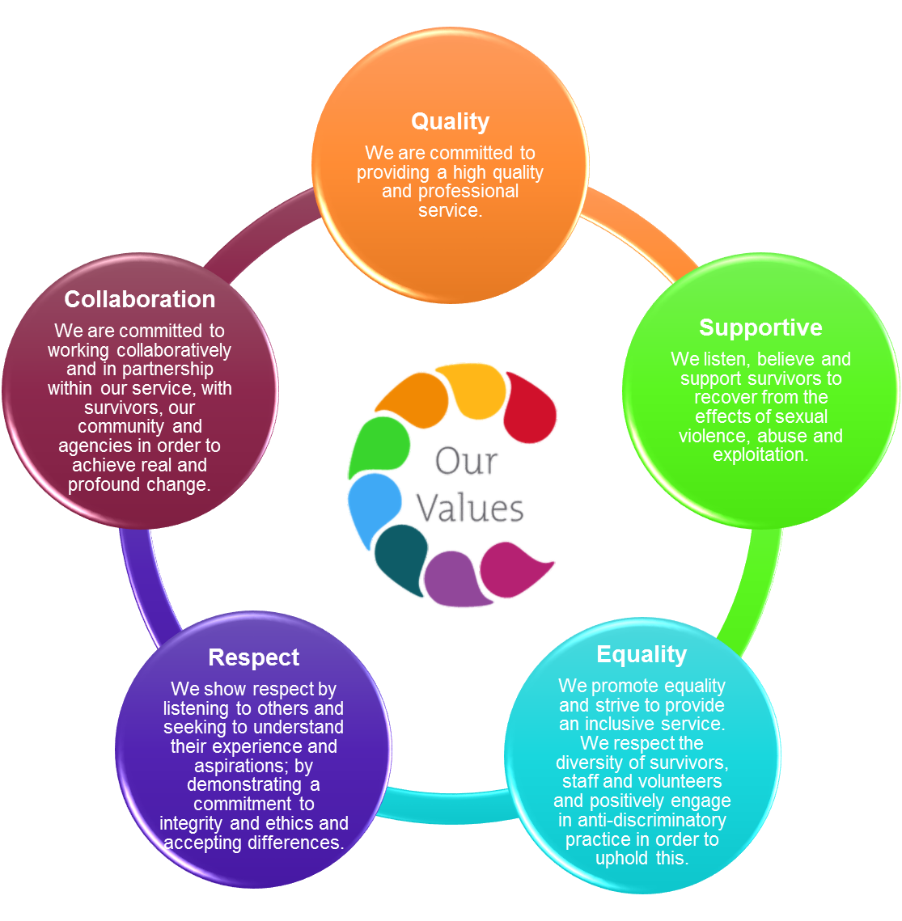

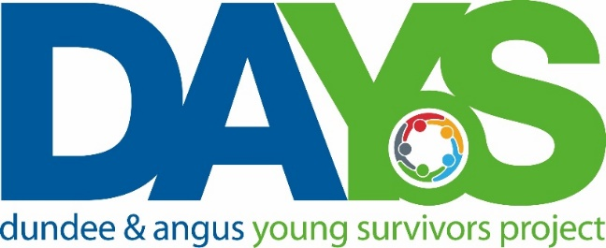

Information about the project

Background
In 2016 WRASAC applied for funding to establish a dedicated service for young people. This was in response to rising numbers of young people seeking support from the centre.
Evidence suggests that early and effective intervention is essential to limiting the long term impacts on young people. Impacts which include poorer outcomes for health, well-being, education and employment.
Following the recruitment of a Senior Young People’s Support Worker at the start of 2017 a service dedicated to young people was established and launched formally in February 2018.
Dundee and Angus Young Survivors Project
The project’s mission is that young people with experience of sexual violence, abuse and exploitation receive age appropriate support where and when they need it. The service offers confidential and professional, emotional and practical support to all young survivors - of all gender identities - aged from 11 to 18; who have experienced sexual violence at any time; and who live in Dundee or Angus.
This post is funded by Children in Need for 3 years and aims to provide a safe space for exploring experiences, improve mental health and rebuild confidence and self-belief. The project will make a difference to young people’s feelings of safety, security and happiness, and will help them to reach their potential.
The young people we support
We support young people whose experiences include child sexual abuse, sexual exploitation, grooming, online abuse, rape, sexual assault, and sexual bullying. Such an experience can generate many difficult thoughts and feelings. A traumatic experience like this can be confusing and make everyday life harder to deal with.

Young people may feel angry, unhappy, frightened or lonely. They could be having flashbacks, nightmares, or panic attacks. It is not unusual for young people to feel they are responsible for what happened and feel shame, or feel like hurting themselves.

We start by listening, allowing the young person to talk about anything. We always believe them and can talk through their experience and why they are not to blame. The support is led by the young person and they only ever have to talk about what they want to.

The support offered is age appropriate; is imaginative and creative; is organised in a variety of contexts; and is flexible in terms of place and time. We also support friends, families and professionals and can provide training to organisations and groups.

Young people are encouraged to get involved in service development and this includes young people who have not experienced sexual violence. All young people are at the centre of the work of this project.
Job Description

Job Title
Young People’s Support and Trauma Worker - Temporary

JOB PURPOSE: To provide holistic support to young survivors of rape, sexual abuse and exploitation.

Salary £25,377.00 (Pro rata)

Contract and Hours Part Time (14 Hours) funded until May 2021

Location: Dundee & Angus

Holiday Entitlement: 33 Annual leave days with 5 Public holidays (including 24th, 25th and 26th December and 1st and 2nd January), with 1 day added per year of service to a maximum of 36 days annual leave after 3 years.

Pension: Employer contribution at 6% to CIS pension fund.

MAIN DUTIES
- Support young survivors with the effects of trauma associated with sexual violence and abuse.
- Provide age appropriate counselling support to young survivors via one to one, group, helpline, email and letter, including carrying a caseload.
- Conduct Introductory Meetings to young survivors when required.
- To support the continued development of Dundee and Angus Young Survivors (DAYS) project.
- Assist DAYS / WRASAC in production of quality monitoring and evaluation.
- Establish and maintain effective working relationships with staff from other agencies to ensure holistic needs of survivors are met.
- Represent DAYS / WRASAC on relevant bodies.
- Develop materials and resources for service users and agencies.
- Assist with development of DAYS/WRASAC policies and procedures.
- Assist in awareness raising of issues around rape sexual abuse and exploitation through training, promotional events, talks, use of social media etc.
- Ensure high quality record of work with survivors on our online Case Management System – OASIS.
- Model a resilient approach to working in the service demonstrating the importance of self-care and boundary setting.
- Use appropriate workload management techniques.

GENERAL TASKS
- Liaise with WRASAC Manager and Board of Governors as required.
- Attend internal and external meetings, training, conferences and seminars where appropriate.
- Liaise and undertake joint work with agencies and other groups.
- Prepare relevant reports and papers as required.

OTHER DUTIES
This job description is a broad picture of the post at the date of preparation. It is not an exhaustive list of all possible duties and it is recognised that jobs change and evolve over time. Consequently, this is not a contractual document and the post holder will be required to carry out any other duties to the equivalent level that are necessary to fulfil the purpose of the job.

Person Specification
________________________________________________________________________________

Job Title
Young People’s Support and Trauma Worker - Temporary

 | ESSENTIAL REQUIREMENTS | DESIRABLE REQUIREMENTS | METHOD OF ASSESSMENT
Professional / Educational Qualifications | Relevant qualification in working with children and young people or willingness to work towards this | Diploma in Counselling | Certificates  Application
Relevant work / other experience | Significant experience in providing trauma based models of support to young survivors (at least one year).  Experience of working with young people with mental health issues or complex support needs.  Experience of writing reports.  Experience of networking and liaising with agencies and other groups.  Experience of partnership working with external agencies. | Experience of group-work.  Experience of developing, delivering and evaluating age appropriate training. | Application  Interview  References
Skills & Knowledge | Demonstrates a knowledge of the impact of trauma on young people and age appropriate support tools / methods.  Knowledge of the impact of rape and sexual abuse on young survivors.  Clearly articulates an understanding and commitment to a feminist analysis of gender based violence.  Understanding and knowledge of Child & Adult Protection Legislation.  Excellent inter-personal and communication skills  Good planning, organisational and prioritisation skills.  Skilled in use of IT for self-administration e.g., Microsoft, excel, email and internet. | Knowledge and understanding of issues for voluntary sector.  Understanding of qualitative and quantitative monitoring and reporting. | Application  Interview  References
Personal Qualities | Demonstrates a resilient approach to the workplace and has clear strategies for managing self.  Evidence of a ‘can-do’ attitude, with the ability and willingness to problem solve, involving others when necessary.  High level of personal commitment to equality and diversity, and ability to work with partners and colleagues from a wide range of backgrounds. |  | Application  Interview  References
Additional Job Requirements | Member of PVG Scheme or willingness to become a member of the PVG Scheme with satisfactory scheme record and/or scheme record update.  Must be able to work flexibly (including evenings and weekends) to meet the needs of WRASAC.  Full Drivers licence and access to a car | . | Application  Interview

Women’s Rape and Sexual Abuse Centre Dundee

Post Applied For:

PERSONAL INFORMATION
(Confidential, the top 3 sheets will be removed and not used for short listing purposes)

1. Personal Details

First Names | Surname
Address  Post Code | Telephone Numbers  Work  Home  Mobile  Email

2. References
Please provide details of a minimum of two referees, one of which must be your most recent employer, one of which must be able to comment on your ability to conduct a research project, and one of which must be able to comment on your ability to engage with vulnerable young people.

Name: Contact prior to interview: Y / N

Address:

Email address:
Telephone number:

Relationship to you:

Name: Contact prior to interview: Y / N

Address:

Email address:
Telephone number:

Relationship to you:
- Period of notice required by current employer?

- Are there any dates when you will be unavailable for interview?

- Are there any adjustments that WRASAC will need to make, should you be invited to interview? Please state what these are.

- Are there any restrictions to your residence in the UK, which might affect your right to take up employment? Yes/No

If Yes, please provide details

- If you are successful in your application will you require a work permit prior to taking up employment? Yes/No

Data Protection Statement
The information that you provide on this form and that obtained from other relevant sources will be used to process your application for employment.

The personal information that you give us will also be used in a confidential manner to help us monitor our recruitment process. If you succeed in your application and take up employment with us, the information will be used in the administration of your employment with us and to provide you with information about us or third party via your payslip. We may also use the information if there is a complaint or legal challenge relevant to this recruitment process.

We may check the information collected, with third parties or with other information held by us. We may also use or pass to certain third parties information to prevent or detect crime, to protect public funds, or in other ways as permitted by law.

By signing the application form we will be assuming that you agree to the processing of sensitive personal data, (as described above), in accordance with our registration with the General Data Protection Regulations.

DECLARATION
I declare that to the best of my knowledge and belief the information given is correct and complete. I understand that WRASAC reserves the right to withdraw the offer of employment or to terminate employment already commenced if the information given to us is inaccurate or misleading in any way. Any job offer is conditional upon receipt of satisfactory references and, if required by WRASAC, any medical reports or disclosure check.

Signed __________________________________________ Date _________________

WRASAC is an Equal Opportunities Employer

Applicant No: _________ (office use only)

- Work Experience – Starting with most recent employer
Please continue on additional sheets if necessary.

Post:
Employer/Organisation:
Address:
From: To:
Main Duties:

Reason for leaving:

Post:
Employer/Organisation:
Address:
From: To:
Main Duties:

Reason for leaving:

Employment Continued

Dates from to | Employers name and address | Post title, responsibilities, experience gained, key achievements | Reason for Leaving, Salary

- Membership of professional bodies

3. Educational, Technical & Professional Qualifications

Institute | Qualification gained | Date Achieved

- WRASAC is a feminist organisation, reflecting on our Vision, Mission and Values, how would you feel about working with the organisation?

- Skills, experience and knowledge (please ensure you meet the essential criteria in the person specification maximum and use no more than 2 full A4 pages)

THANK YOU FOR TAKING THE TIME TO COMPLETE THIS FORM
Your completed application should be sent to recruitment@wrasac.org.uk

