Manager Recruitment Pack
WRASAC Dundee & Angus is a company limited by guarantee, registered with OSCR and registered in Scotland as company number SC241372 and charity number SC009070.
Business: 01382 205556
Support: 01382 201291
info@wrasac.org.uk
support@wrasac.org.uk
www.wrasac.org.uk

Dear Applicant

Thank you for your interest in applying for a post with Women’s Rape and Sexual Abuse Centre. Please find enclosed the following documents:-

- Advice on completing your application form
- Information about WRASAC
- Job Description and Person Specification

Please do not send a curriculum vitae as this will not be considered.

Please note, all applications and relevant recruitment documents will be held confidentially and destroyed after 6 months, apart from documents relating to the successful applicant.

Your completed application should be submitted via email by sending it to recruitment@wrasac.org.uk.

Closing Date is 12pm 5th February 2020

Interviews will be held on the week beginning 17th February 2020

Please note this post is 30 Hours per Week.

We would appreciate it if you would take the time to complete this equal opportunities survey: Click Here

We look forward to receiving your completed application form.

Please note only women need apply under Schedule 9, Part 1 of the Equality Act 2010

Yours sincerely

Angela Wilson
Chair, WRASAC – Dundee & Angus

2 Dudhope Street, Dundee, DD1 1JU
WRASAC Dundee & Angus is a company limited by guarantee, registered with OSCR and registered in Scotland as company number SC241372 and charity number SC009070.

Introduction
The Women’s Rape and Sexual Abuse Centre – Dundee and Angus (WRASAC) has been supporting survivors of rape, sexual abuse and exploitation and raising awareness about the damaging effects of sexual violence since 1984. We are a registered charity and a company limited by guarantee.

WRASAC has a dynamic and growing team of staff and volunteers and an annual income of just under £600,000 per year from a diverse range of funders.

We have excellent relationships and partnership working across the Dundee and Angus area and are members of a number of strategic groups, including:

- Dundee & Angus Violence Against Women Partnerships
- Dundee Vulnerable Adolescent Partnership
- Dundee Substance Misuse Strategic Planning Group
- Scottish Government Commercial Sexual Exploitation Working Group
- Encompass Network (network of organisations that work in partnership with people involved in prostitution)
- Rape Crisis Scotland Network

Our Services
We provide a range of services to survivors of sexual violence, abuse and exploitation including:

Advocacy
Works with survivors who are thinking about or are engaging with the Criminal Justice System. This includes support to report to the police, with court appearances, accessing the Sexual Assault and Referral Network (forensic examination for those not wishing to report in immediate aftermath of a sexual assault) and supports them with any civil protective orders.

Dundee and Angus Young Survivors (DAYS)
This service offers confidential and professional, emotional and practical support to all young survivors - of all gender identities - aged from 11 to 18; who have experienced sexual violence at any time; and who live in Dundee or Angus.

Vice Versa
Offers support and advocacy to women involved in prostitution and commercial sexual exploitation.

Women’s Support Service
Provides trauma informed support to survivors in a one to one and group setting. We have an Outreach Support Service that operates in across Angus.

WRASAC also works in a variety of ways to improve service provision to all survivors regardless of where they may present for support. We participate in many partnerships across Dundee and Angus, Scotland and even across Europe.

Most importantly, though, we are in the business of working within our communities to change attitudes so we can, in the longer term, prevent and reduce sexual violence from happening in the first place. We do this through:

Prevention Work
We have a dedicated Prevention Worker who works in schools, colleges and youth settings in Dundee and Angus delivering the Rape Crisis Scotland Prevention Pack.

Training and Awareness Raising
We provide a monthly Information Session to staff from Dundee and Angus. We also provide training on a range of topics including, dealing with disclosures, understanding sexual violence and dealing with trauma. Additionally we run community awareness raising events, like our Reclaim the Night march each year.

Vision, Values and Strategic Priorities
In 2017-18, after a long period of reviewing and consulting with staff, volunteers, trustees, survivors and partner agencies we developed our new Strategic Plan and updated our Vision, Mission Statement and Values.

Our Vision
For a world free from sexual violence, abuse and exploitation and a society in which everyone has equality, freedom and choices to live the lives they want and thrive.

Our Mission
To support survivors who have experienced any form of sexual violence, abuse or exploitation in their lives.

To promote equality and raise public awareness of the routes of sexual violence and its damaging and life-changing effects.

Our Values
We believe first and foremost that perpetrators of rape, sexual abuse and exploitation are responsible for their actions – not survivors.

We are a feminist organisation which means we recognise that all forms of rape, sexual abuse and exploitation are acts of violence, that disproportionately affects women and children, involving the abuse of power and control, are a breach of human rights and are fundamentally rooted in gender inequality.
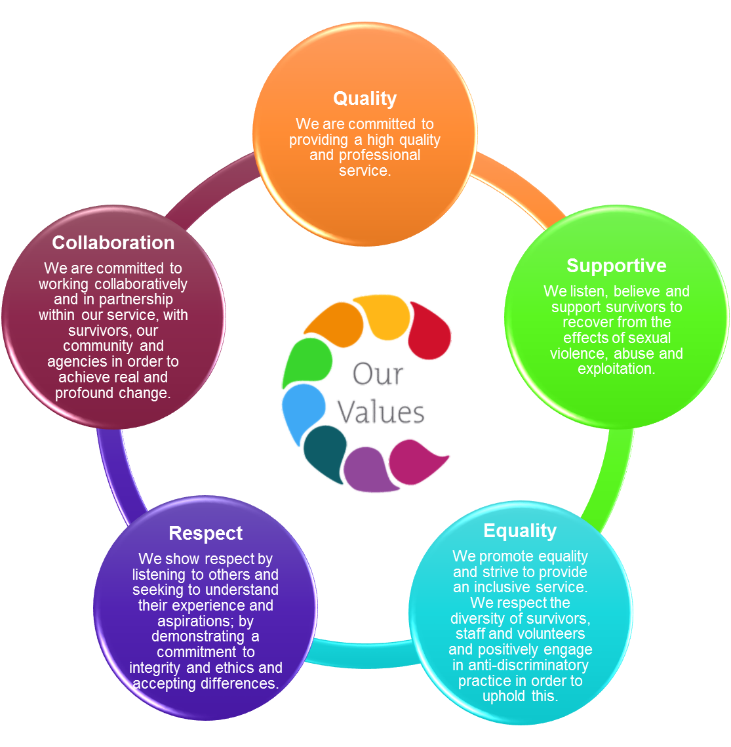

Our Strategic Priorities

Organisational Structure

The Board of Governors is elected from the members of WRASAC. The Board members are volunteers. The Board of Governors have full responsibility for the financial, legal and personnel matters of WRASAC.

The Board have recently agreed a change in structure introducing the role of Deputy Manager which will take responsibility for overseeing the delivery of all direct services.

ADVICE ON COMPLETING YOUR APPLICATION FORM

As part of WRASAC’s commitment to equal opportunities, candidates for each post are treated equally. Application forms are the only basis on which the first selection is made to decide whom to call for interview. Therefore only information, which appears on the form (and continuation pages), can be considered. It is very important that your completed form contains both the information we want about your skills and experience and the information you want to give us. These advice notes are intended to help you to complete your form effectively.

1 Read all the information provided especially the job description and person specification. These outline the duties you would be expected to carry out in this post and lists the skills, knowledge and abilities that the short listing/interview panel will be looking for.

2 Section 4 asks you to note down your general experience and is the most important part of your application. This is your chance to explain why you are suitable for the job. It is not enough to say you have the experience – you must demonstrate experience and skills with specific examples. Relevant experience may be from your current or previous jobs or from out with formal employment.

3 We have lots of information about our service on our website www.wrasac.org.uk. We have also attached our Annual Accounts and Strategic Plan for your information.

4 Do not send your CV in addition to or in place of a completed application form as it will not be considered by the short-listing panel.

5 A Protection of Vulnerable Groups and Non Police Personnel Vetting is required as part of the job.

6 Completing the Equal Opportunities Monitoring Form is voluntary but the information requested here is useful as it allows us to monitor the effectiveness of our policy of equal opportunities in employment.

7 All applicants must complete all parts of the application form.

8 Application forms must arrive on time forms arriving late will not be considered.

9 References are normally taken up for the short listed applicants before interview. If you do not wish one or all references to be taken up at that point please indicate on the relevant page. It is our policy not to make a job offer without taking up references.

Job Description & Person
Specification
Job Title
Manager

JOB PURPOSE: To provide inspirational leadership, strategic direction and high quality management across WRASAC. To build capacity and resources for WRASAC services, including leading our fundraising and having overall responsibility for the financial management of WRASAC. To develop and maintain good working relationships and influence with stakeholders, the media and the local community, raising the profile of the organisation and increasing awareness and understanding of sexual violence.

Responsible to: Chair of WRASAC Board of Trustees
Salary: £44,017 (pro rata)
Hours: 30 hours per week
Location: Dundee
Holiday Entitlement: 33 Days plus 5 Public Holidays (rising to 36 Days after 3 years’
service) (pro-rata)
Pension: Employer contribution at 6% to pension fund.

MAIN DUTIES
Responsible under the general direction of the Board for the overall performance of The Women’s Rape and Sexual Abuse Centre (WRASAC) including planning, development, monitoring and review of all services delivered by WRASAC.

- Under the direction of the Board of Trustees, take responsibility for the implementation of the strategic plans of the organisation. Contribute to ongoing business planning and provide strategic direction to all staff in accordance with WRASAC’s Strategic Plan. Ensure appropriate structures and mechanisms are in place and working effectively to achieve its stated outcomes and objectives, and ensure these are reviewed and amended as needed to drive continuous organisational improvement

- Assist the Board to effectively monitor, review and evaluate the organisation’s policies, procedures, finances, risk management, and future development needs by attending Board meetings, reporting on all aspects of strategic and operational planning, management and compliance tasks. Provide assurance through regular monitoring and reporting to the Board of Directors that the organisation is achieving its stated outcomes and objectives and that planned organisational performance and high quality delivery are being achieved and communicating organisational risks and challenges in a timely way. Act as the Company Secretary.

- Support the Board to develop and maintain appropriate governance structures and engage appropriately with funders, service users, members, staff and other stakeholders. Ensure effective channels of communication between the Board, the membership, WRASAC staff and other stakeholders.

- Working closely with the Finance Worker and the Board, to oversee the management of the organisation’s budgets, including taking responsibility for planning, monitoring and devolving budgetary responsibilities as appropriate, ensuring appropriate financial management practices are in place.

- Have an overview of the organisations finances, identifying any funding gaps and develop options for closing these, take the lead on the development of a fundraising strategy, completing funding applications, driving corporate and community fundraising

- Take responsibility for the support and development of the Deputy Manager in their role of overseeing the provision of day to day services and practice development of staff. Support the senior staff in achieving WRASAC objectives. Appropriately delegate tasks which promote personal development and organisational sustainability. Fostering a culture in which individuals and teams are enabled to achieve outcomes and work together productively by ensuring the foundations are in place, including arrangements for good communications, cross organisational working, and staff / volunteer engagement and support.

- Ensure the establishment mechanisms for listening to the views of partners, staff, funders and beneficiaries on the organisation’s performance.

- Enable the organisation to develop and maintain a culture which reflects the values of RCS and WRASAC and affirms that it is a workplace where quality, support, equality, respect and collaboration are recognised as valued and important.

- Ensure effective service delivery and HR policies and procedures are in place. Support the Deputy Manager with staff management issues, ensuring all legislative and good practice requirements are followed including the provision of high quality support and supervision.

- Ensure that there are regular, clear and multi- channel internal communications across WRASAC (e.g. team meetings, e-mails etc.) and that staff understand the vision, values and strategy of the organisation and how their work aligns to and supports their implementation

- Act as the named, responsible person to oversee the development, implementation and monitoring of health and safety across all WRASAC activities, employees and service users. Ensuring the development, reviewing and updating of health and safety policies, procedures and organisational risk assessments happens.

- Act as the senior representative of WRASAC including co-ordination of WRASAC’s public and media profile. Promote the work of WRASAC in the local and wider community (providing training and awareness raising) maintaining a positive leadership profile of WRASAC..

- Promote effective partnership working with key stakeholders, including participation at relevant multi-agency / strategic partnerships.

- Ensure that principles of equality and diversity are embedded throughout all aspects of WRASAC operational and organisational activities. Take a proactive role in promoting equality and anti-discriminatory practice throughout all aspects of the service.

- Model a resilient approach to working in the service demonstrating the importance of self-care and boundary setting.

- Show a commitment to ongoing personal development

- Perform other duties as reasonably required by the Board of Trustees

This job description is a broad picture of the post at the date of preparation. It is not an exhaustive list of all possible duties and it is recognised that jobs change and evolve over time. Consequently, this is not a contractual document and the post holder will be required to carry out any other duties to the equivalent level that are necessary to fulfil the purpose of the job.

PERSON SPECIFICATION

 | ESSENTIAL REQUIREMENTS | DESIRABLE REQUIREMENTS | METHOD OF ASSESSMENT
Professional / Educational Qualifications |  | Management / Leadership qualification | Certificates Application
Relevant work / other experience | - At least 2 years in a senior management position  - Change management  - Preparing and delivering business plans and strategies  - Partnership working with external organisations, funders and policy makers  - Experience of writing funding applications and raising significant amounts of funds  - Financial management and budget setting  - Leadership and good governance  - Using a collaborative management style  - Delivering a healthy and safe workplace  - Developing and implementing policies and procedures  - Prioritising effectively, and balancing potentially competing areas of work  - Experience of using Digital Technology to enhance organisation and personal performance. | - Working in the violence against women field  - Knowledge of HR and H&S Legislation and good practice  - Experience of working to a board of Trustees | Application Interview References
Skills & Knowledge | - Excellent track record in delivery of services, ideally in not for profit sector  - Clearly articulates an understanding and commitment to a feminist analysis of gender based violence.  - Excellent interpersonal skills with a range of people including staff, service users, donors, volunteers and partner organisations  - Understanding of qualitative and quantitative monitoring and reporting.  - Good planning, organisational and prioritisation skills.  - Excellent communication, numeracy, literacy and IT skills | - Knowledge of the national and local strategies on violence against women  - Understanding and knowledge of Child & Adult Protection Legislation. | Application Interview References
Personal Qualities | - An interest in social justice and a genuine desire to support those affected by rape, sexual abuse and / or exploitation.  - A commitment to the values and work of WRASAC.  - Demonstrates a resilient approach to the workplace and has clear strategies for managing self.  - Evidence of a ‘can-do’ attitude, with the ability and willingness to problem solve, involving others when necessary.  - High level of personal commitment to equality and diversity, and ability to work with partners and colleagues from a wide range of backgrounds.  - Demonstrates a commitment to continuous professional development |  | Application Interview References
Additional Job Requirements | - Member of PVG Scheme or willingness to become a member of the PVG Scheme with satisfactory scheme record and/or scheme record update.  - Must be able to work flexibly (including evenings and weekends) to meet the needs of WRASAC.  - Full Drivers licence and access to a car.  - All candidates must have the right to work in the UK  - Occupational Requirement under Schedule 9 (part 1) of the Equality Act 2010 applies. Due to contact with service users the post holder must be female in accordance with the Sex Discrimination Act 1975 Part 7 (2) (e). |  | Application Interview

