



Women’s Family Safety Worker

Business: 01382 205556
Support: 01382 201291
info@wrasac.org.uk
support@wrasac.org.uk
www.wrasac.org.uk

Dear Applicant

Thank you for your interest in applying for a post with Women’s Rape and Sexual Abuse Centre. Please find enclosed the following documents: -

- Information about WRASAC
- Advice on completing your application form.
- Job Description and Person Specification

Please do not send a curriculum vitae as this will not be considered.

Please note, all applications and relevant recruitment documents will be held confidentially and destroyed after 6 months, apart from documents relating to the successful applicant.

Your completed application should be submitted via email by sending it to recruitment@wrasac.org.uk.

Closing date is Sunday 23rd July at midnight.

Invites to interview will go out Friday 28th July.

Interviews will be held week commencing 7th August.

Please note this post is 35 hours per week.

We look forward to receiving your completed application form. Enquiries about this position are welcome by phoning or emailing recruitment@wrasac.org.uk.

Yours sincerely

Katie Hardy-Jensen
Manager

Sangobeg House, 4 Francis Street, Dundee, DD3 8HH
WRASAC Dundee & Angus is a company limited by guarantee, registered with OSCR and registered in Scotland as company number SC241372 and charity number SC009070.

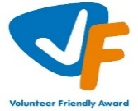



Information about WRASAC

The Women’s Rape and Sexual Abuse Centre – Dundee and Angus (WRASAC) has been supporting survivors of rape, sexual abuse and exploitation and raising awareness about the damaging effects of sexual violence since 1984. We are a registered charity and a company limited by guarantee.

WRASAC has a dynamic team of 34 staff members, 10 volunteers, 2 Students and 2 Sessional Workers. The organisation has an annual income of just over 1 million pounds per year.
We provide a range of services to survivors of sexual violence, abuse and exploitation including:
Women’s Support Service
The Women’s Support Service provides support to self-identifying women (over 18) who have experienced rape, sexual abuse and/or exploitation.
Support can include 1:1 session in the centre or on outreach, advocacy support and signposting to other organisations for support.
Dundee and Angus Young Survivors (DAYS)
We support all young people of any gender aged between 8 and 18 who live in Dundee or Angus and have experienced any type of sexual abuse.
We take a flexible approach to planning support to best meet the needs of the young person, this can be school, home, community or at our office.
1:1 Support - We offer emotional support to survivors. Each session is a safe and confidential space for survivors to process the trauma they have experienced at their own pace. We do this by using a range of therapeutic interventions and tools which are survivor centred.
Group work support - We various creative groups and peer support groups all of which aims to reduce isolation and extend social circles. The aim of these are to build survivors support networks and build survivors confidence, reducing isolation and feelings of blame and shame.
Family and Friends
We can also provide support to family, friends, partners and agency workers to help them understand the impact of sexual violence and cope with their feelings whilst supporting a survivor.

Vice Versa
Vice Versa provides support to adult women who have been involved, are currently involved or are at risk of being involved in Commercial Sexual Exploitation (CSE). The women we support generally experience multiple disadvantage which may include substance use, homelessness, physical and mental health issues, welfare issues and extensive historical and ongoing trauma.
The aim of the project is to provide women with safety and stabilisation support and with all issues that impact on their involvement in CSE. Support can include 1:1 session in the centre or on outreach, supporting to attend appointments and groups, advocacy support and signposting to other organisations or support. Support is led entirely by the women and their needs and priorities.
Justice Advocacy Service
Our Justice Advocacy Service provides support throughout the criminal justice process. We can support survivors with their decision to report the incident to the Police or not.

If they decide to report to the Police, we can go with survivors while they provide their statement and if they would prefer, we can get updates on the investigation from the Police on survivor’s behalf.

If the case is reported to the Crown Office and Procurator Fiscal Service (COPFS), we can liaise with survivors assigned Victim Information and Advice Officer (VIA) and talk to them about special measures that can be put in place to make giving evidence as easy as possible.

Advocacy Workers can go into the court room with survivors (as an In Court Supporter) while they give evidence, and they can provide support around verdicts and sentencing.

Advocacy workers can also provide post court support to survivors.

Dundee Women’s Hub
WRASAC supported by partners across the Dundee area are responsible for the setting up, development and facilitation of Dundee Women’s Hub (DWH).

The main aim of the DWH is to increase capacity and co-ordination of services to respond to the needs of the women experiencing substance use and multiple disadvantage. The hub will improve access to substance use and related services for women in Dundee with the overall goal of improving physical and emotional wellbeing for women who experience substance use and multiple disadvantages.

Prevention Work
We have a dedicated Prevention Worker who works in schools, colleges and youth settings in Dundee and Angus delivering the Rape Crisis Scotland Prevention Pack.
Gender Based Violence (GBV) Team
The GBV Team is made up of a Community Engagement Worker who focuses on increasing access to our service and raising awareness around our service and issues related to sexual violence.
Two Learning and Development Officers who are co-located between WRASAC and Dundee City Council who provide training and support and strategic direction in relation to GBV and Trauma across the VAWG network and council in Dundee.
Training and Awareness Raising
Staff across our teams provide training sessions We provide WRASAC Information Session’s to staff from Dundee and Angus. We also provide training on a range of topics including understanding sexual violence and dealing with trauma. Additionally, we run community awareness raising events, like our Reclaim the Night March each year.

Vision, Values and Strategic Priorities

In 2017-18, after a prolonged period of reviewing and consulting with staff, volunteers, trustees, survivors, and partner agencies we developed our new Strategic Plan and updated our Vision, Mission Statement and Values.

Our Vision
For a world free from sexual violence, abuse and exploitation and a society in which everyone has equality, freedom and choices to live the lives they want and thrive.

Our Mission
To support survivors who have experienced any form of sexual violence, abuse or exploitation in their lives.
To promote equality and raise public awareness of the routes of sexual violence and its damaging and life-changing effects.

Our Values
We believe first and foremost that perpetrators of rape, sexual abuse and exploitation are responsible for their actions – not survivors.

We are a feminist organisation which means we recognise that all forms of rape, sexual abuse and exploitation are acts of violence, that disproportionately affects women and children, involving the abuse of power and control, are a breach of human rights and are fundamentally rooted in gender inequality.

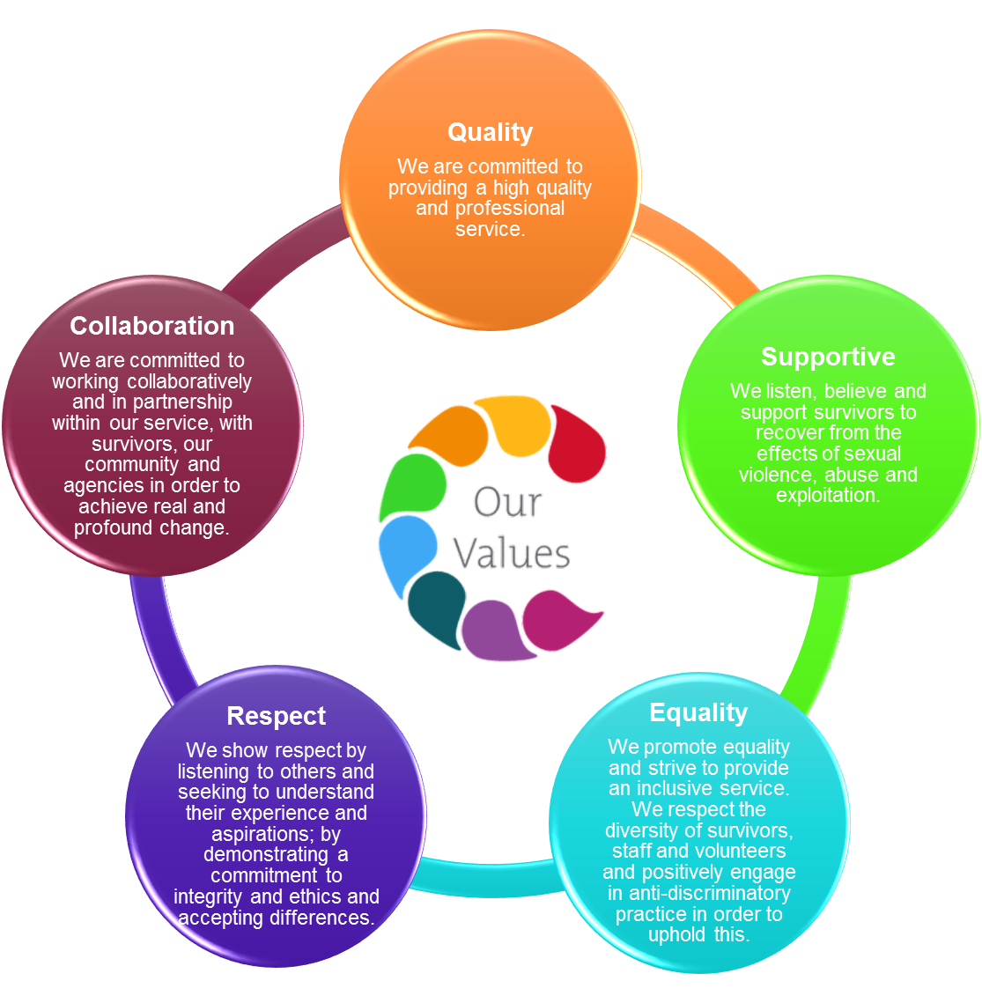

Our Strategic Priorities

ADVICE ON COMPLETING YOUR APPLICATION FORM

As part of WRASAC’s commitment to equal opportunities, candidates for each post are treated equally. Application forms are the only basis on which the first selection is made to decide whom to call for interview. Therefore, only information, which appears on the form (and continuation pages), can be considered. It is very important that your completed form contains both the information we want about your skills and experience and the information you want to give us. These advice notes are intended to help you to complete your form effectively.

1 Read all the information provided especially the job description and person specification. These outline the duties you would be expected to carry out in this post and lists the skills, knowledge and abilities that the short listing/interview panel will be looking for.

2 Section 4 asks you to note down your general experience and is the most important part of your application. This is your chance to explain why you are suitable for the job. It is not enough to say you have the experience – you must demonstrate experience and skills with specific examples. Relevant experience may be from your current or previous jobs or from out with formal employment.

3 We have lots of information about our service on our website www.wrasac.org.uk.

4 Do not send your CV in addition to or in place of a completed application form as it will not be considered by the short-listing panel.

5 A Protection of Vulnerable Groups and Non-Police Personnel Vetting is required as part of the job.

6 Completing the Equal Opportunities Monitoring Form is voluntary, but the information requested here is useful as it allows us to monitor the effectiveness of our policy of equal opportunities in employment.

7 All applicants must complete all parts of the application form.

8 Application forms must arrive on time, forms arriving late will not be considered.

9 References are normally taken up for the short-listed applicants before interview. If you do not wish one or all references to be taken up at that point please indicate on the relevant page. It is our policy not to make a job offer without taking up references.

Job Description & Person
Specification
Job Title: Women and Family Safety Worker (Angus)

JOB PURPOSE: To provide support to women who are survivors of gender-based violence and whose partners or ex partners are subject to reports, risk assessments, or perpetrator programme interventions being delivered by, or on behalf of, Angus Justice Services.
Responsible to: Deputy Manager
Salary: £27,382 moving to £29,465 after 12 months in post
Hours: 35 hours; funded July 30th 2025 (with opportunity to seek further funding)
Location: Covering Angus area and potential travel to Dundee office for Meetings as and when required
Holiday Entitlement: 33 Days plus 5 Public Holidays
(rising to 36 Days after 3 years ‘Service)

Pension: Employer contribution at 6% to pension fund.

MAIN DUTIES

- To provide support to women who are survivors of gender-based violence in particular sexual violence and abuse and whose partners or ex partners are subject to reports, risk assessments, or perpetrator programme interventions being delivered by, or on behalf of, Angus Justice Services.

- To embrace a trauma informed approach when supporting women and children.

- To ensure women and children’s (if applicable) needs are fully assessed and individually tailored support and safety plans are in place and appropriate referrals are made as and when required.

- To provide targeted interventions and information to women, building strong and trusted relationships.

- To provide 1:1 support to enable survivors to understand the impact of domestic abuse and coercive control.

- To contribute to the work of Angus Justice Services by liaising closely with colleagues in the men’s service to assess and manage risk and to appropriately share information relating to risk and safety.

- To attend monthly meetings with Angus Justice Social Workers to update risk assessments and safety plans.

- To attend multi-agency meetings to advocate on behalf of women and their children.

- Establish and maintain effective working relationships with staff from other agencies to ensure holistic needs of survivors are met.

- Assist WRASAC in production of quality monitoring and evaluation.

- To provide information data reports and updates as required to WRASAC and Angus Council.

- To participate and engage in supervision with your line manager

- To take responsibility for continuous personal and professional development.

- Travel throughout Angus is required in this role. You will also have to travel to our office in Dundee for Meetings.

- Develop materials and resources for service users and agencies.

- Assist with development of WRASAC policies and procedures.

- Ensure high quality record of work with survivors on our online Case Management System – OASIS.

- Model a resilient approach to working in the service demonstrating the importance of self-care and boundary setting.

- Use appropriate workload management techniques.
This job description is a broad picture of the post at the date of preparation. It is not an exhaustive list of all possible duties and it is recognised that jobs change and evolve over time.

Consequently, this is not a contractual document and the post holder will be required to carry out any other duties to the equivalent level that are necessary to fulfil the purpose of the job.

PERSON SPECIFICATION – Women and Families Safety Worker

 | ESSENTIAL REQUIREMENTS | DESIRABLE REQUIREMENTS | METHOD OF ASSESSMENT
Professional / Educational Qualifications | SVQ Level 3 or equivalent professional qualification gained in a relevant subject, eg social science, community justice, social support, promoting independence, community support | COSCA Certificate in Counselling Skills or a willingness to work towards it.  Safe lives Training | Certificates  Application
Relevant work / other experience | Knowledge of gender-based violence and at least one year’s previous work experience working in a similar support role e.g. Domestic Abuse practitioner  Experience of working with women with mental health issues and/or complex support needs  Experience of writing reports.  Experience of networking and liaising with agencies and other groups.  Experience of partnership working with external agencies.  Experience of assessing the needs of women and children and developing safety plans to address identified risks | Experience of developing, delivering and evaluating training. | Application  Interview  References
Skills & Knowledge | Clearly articulates an understanding and commitment to a feminist analysis of gender based violence.  Knowledge of the impact of gender based violence on women and children  Knowledge of the needs of minority and refugee women experiencing gender-based violence.  Knowledge and understanding of Honour Based Violence, Forced Marriage and Female Genital Mutilation and the impacts on women, children and society.  Ability to empower and encourage the participation and engagement of women  Good planning, organisational and prioritisation skills.  Excellent inter-personal and communication skills  Knowledge of current Adult and Child Protection legislation within Scotland  Ability to develop trusting relationships with women  Ability to work supportively with colleagues working with male perpetrators of gender-based violence  Ability to advocate on behalf of women and their children, and to liaise with a range of agencies to promote women and children’s safety  Ability to be flexible and respond to crises in a calm and reassuring manner  Excellent organisational skills and ability to manage own workload  Excellent communication skills  Good IT Skills including being proficient in the use of Microsoft Office | Knowledge and understanding of issues for voluntary sector.  Knowledge of welfare rights issues | Application  Interview  References
Personal Qualities | Demonstrates a resilient approach to the workplace and has clear strategies for managing self.  Evidence of a ‘can-do’ attitude, with the ability and willingness to problem solve, involving others when necessary.  Strong team player, committed to an ethos of continuous professional improvement  Committed to a trauma informed approach  Empathic and compassionate  High level of personal commitment to equality and diversity, and ability to work with partners and colleagues from a wide range of backgrounds. |  | Application  Interview  References
Additional Job Requirements | Member of PVG Scheme or willingness to become a member of the PVG Scheme with satisfactory scheme record and/or scheme record update.  Must be able to work flexibly (may include working evenings and weekends) to meet the needs of the service.  Full Drivers licence and access to a car as travel is required throughout the Angus area. |  | Application  Interview

Women’s Rape and Sexual Abuse Centre Dundee

Post Applied For:

1. Personal Details

First Names: | Surname:
Address:  Post Code: | Contact information:  Mobile:  Email:

2. References
Please provide details of a minimum of two referees, one of which must be your most recent employer.

Name: Contact prior to interview: Y/N

Address:

Email address:
Telephone number:

Relationship to you:

Name: Contact prior to interview: Y/N

Address:

Email address:
Telephone number:

Relationship to you:

- Period of notice required by current employer?

- Are there any dates when you will be unavailable for interview?

- Are there any adjustments that WRASAC will need to make, should you be invited to interview? Please state what these are.

- Are there any restrictions to your residence in the UK, which might affect your right to take up employment? If Yes, please provide details

- If you are successful in your application will you require a work permit prior to taking up employment?

- Do you hold a full drivers licence?

- Do you currently have car insurance for business use?

- Are you related to any employee or board member of WRASAC Dundee and Angus? Yes / No If yes, please provide details:

- Are you or have you ever been a member of WRASAC Dundee and Angus Board of Directors? Yes / No If yes, please provide details:
- Where did you see this vacancy advertised?

Data Protection Statement
The information that you provide on this form and that obtained from other relevant sources will be used to process your application for employment.

The personal information that you give us will also be used in a confidential manner to help us monitor our recruitment process. If you succeed in your application and take up employment with us, the information will be used in the administration of your employment with us and to provide you with information about us or third party via your payslip. We may also use the information if there is a complaint or legal challenge relevant to this recruitment process.

We may check the information collected, with third parties or with other information held by us. We may also use or pass to certain third parties information to prevent or detect crime, to protect public funds, or in other ways as permitted by law.

By signing the application form we will be assuming that you agree to the processing of sensitive personal data, (as described above), in accordance with our registration with the Data Protection Commissioner.

DECLARATION
I declare that to the best of my knowledge and belief the information given is correct and complete. I understand that WRASAC reserves the right to withdraw the offer of employment or to terminate employment already commenced if the information given to us is inaccurate or misleading in any way. Any job offer is conditional upon receipt of satisfactory references and, if required by WRASAC, any medical reports or disclosure check.

Signed
Date

WRASAC is an Equal Opportunities Employer

Applicant No: _________ (office use only)

- Work Experience – Starting with most recent employer
Please continue on additional sheets if necessary.

Post:
Address:
From: To:
Main Duties:

Reason for leaving:

Post:
Address:
From: To:
Main Duties:

Reason for leaving:

Employment Continued

Dates from to | Employers name and address | Post title, responsibilities, experience gained, key achievements | Reason for Leaving, Salary

- Membership of professional bodies

3. Educational, Technical & Professional Qualifications

Institute | Qualification gained | Date Achieved

- Skills, experience and knowledge (please refer to the person specification)

Your completed application should be submitted via email by sending it to recruitment@wrasac.org.uk

