Board of Governors
Board Secretary
Business: 01382 205556
Support: 01382 201291
info@wrasac.org.uk
support@wrasac.org.uk
www.wrasac.org.uk

Dear Applicant

Thank you for your interest in applying for a post with Women’s Rape and Sexual Abuse Centre. Please find enclosed the following documents: -

- Information about WRASAC
- Advice on completing your application form
- Job Description and Person Specification

Please do not send a curriculum vitae as this will not be considered.

Please note, all applications and relevant recruitment documents will be held confidentially and destroyed after 6 months, apart from documents relating to the successful applicant.

Your completed application should be submitted via email by sending it to recruitment@wrasac.org.uk.

All posts require a female applicant and is exempt under Schedule 9, Part 1 of the Equality Act 2010, Schedule 9, and Part 1. Section 7(2) e of the Sex Discrimination Act 1975.

We look forward to receiving your completed application form. Enquiries about this position are welcome by phoning or emailing recruitment@wrasac.org.uk.

Yours sincerely

Katie Hardy-Jensen
Manager

Sangobeg House, 4 Francis Street, Dundee, DD3 8HH
WRASAC Dundee & Angus is a company limited by guarantee, registered with OSCR and registered in Scotland as company number SC241372 and charity number SC009070.
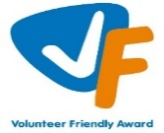

INFORMATION ABOUT WRASAC

The Women’s Rape and Sexual Abuse Centre – Dundee and Angus (WRASAC) has been supporting survivors of rape, sexual abuse and exploitation and raising awareness about the damaging effects of sexual violence since 1984. We are a registered charity and a company limited by guarantee.

WRASAC has a dynamic team of 34 staff members, 10 volunteers and 2 Students. The organisation has an annual income of just over 1 million pounds per year.
We provide a range of services to survivors of sexual violence, abuse and exploitation including:
Women’s Support Service
The Women’s Support Service provides support to self-identifying women (over 18) who have experienced rape, sexual abuse and/or exploitation.
Support can include 1:1 session in the centre or on outreach, advocacy support and signposting to other organisations for support.
Dundee and Angus Young Survivors (DAYS)
We support all young people of any gender aged between 8 and 18 who live in Dundee or Angus and have experienced any type of sexual abuse.
We take a flexible approach to planning support to best meet the needs of the young person, this can be school, home, community or at our office.
1:1 Support - We offer emotional support to survivors. Each session is a safe and confidential space for survivors to process the trauma they have experienced at their own pace. We do this by using a range of therapeutic interventions and tools which are survivor centred.
Group work support - We various creative groups and peer support groups all of which aims to reduce isolation and extend social circles. The aim of these are to build survivors support networks and build survivors confidence, reducing isolation and feelings of blame and shame.
Family and Friends
We can also provide support to family, friends, partners and agency workers to help them understand the impact of sexual violence and cope with their feelings whilst supporting a survivor.

Vice Versa
Vice Versa provides support to adult women who have been involved, are currently involved or are at risk of being involved in Commercial Sexual Exploitation (CSE). The women we support generally experience multiple disadvantage which may include substance use, homelessness, physical and mental health issues, welfare issues and extensive historical and ongoing trauma.
The aim of the project is to provide women with safety and stabilisation support and with all issues that impact on their involvement in CSE. Support can include 1:1 session in the centre or on outreach, supporting to attend appointments and groups, advocacy support and signposting to other organisations or support. Support is led entirely by the women and their needs and priorities.
Justice Advocacy Service
Our Justice Advocacy Service provides support throughout the criminal justice process. We can support survivors with their decision to report the incident to the Police or not.

If they decide to report to the Police, we can go with survivors while they provide their statement and if they would prefer, we can get updates on the investigation from the Police on survivor’s behalf.

If the case is reported to the Crown Office and Procurator Fiscal Service (COPFS), we can liaise with survivors assigned Victim Information and Advice Officer (VIA) and talk to them about special measures that can be put in place to make giving evidence as easy as possible.

Advocacy Workers can go into the court room with survivors (as an In Court Supporter) while they give evidence, and they can provide support around verdicts and sentencing.

Advocacy workers can also provide post court support to survivors.

Dundee Womens Hub
WRASAC supported by partners across the Dundee area are responsible for the setting up, development and facilitation of Dundee Womens Hub (DWH).

The main aim of the DWH is to increase capacity and co-ordination of services to respond to the needs of the women experiencing substance use and multiple disadvantage. The hub will improve access to substance use and related services for women in Dundee with the overall goal of improving physical and emotional wellbeing for women who experience substance use and multiple disadvantages.
Prevention Work
We have a dedicated Prevention Worker who works in schools, colleges and youth settings in Dundee and Angus delivering the Rape Crisis Scotland Prevention Pack.
Gender Based Violence (GBV) Team
The GBV Team is made up of a Community Engagement Worker who focuses on increasing access to our service and raising awareness around our service and issues related to sexual violence.
Two Learning and Development Officers who are co-located between WRASAC and Dundee City Council who provide training and support and strategic direction in relation to GBV and Trauma across the VAWG network and council in Dundee
Training and Awareness Raising
Staff across our teams provide training sessions We provide WRASAC Information Session’s to staff from Dundee and Angus. We also provide training on a range of topics including understanding sexual violence and dealing with trauma. Additionally, we run community awareness raising events, like our Reclaim the Night March each year.

Vision, Values and Strategic Priorities

In 2017-18, after a long period of reviewing and consulting with staff, volunteers, trustees, survivors and partner agencies we developed our new Strategic Plan and updated our Vision, Mission Statement and Values.

Our Vision
For a world free from sexual violence, abuse and exploitation and a society in which everyone has equality, freedom and choices to live the lives they want and thrive.

Our Mission
To support survivors who have experienced any form of sexual violence, abuse or exploitation in their lives.
To promote equality and raise public awareness of the routes of sexual violence and its damaging and life-changing effects.

Our Values
We believe first and foremost that perpetrators of rape, sexual abuse and exploitation are responsible for their actions – not survivors.

We are a feminist organisation which means we recognise that all forms of rape, sexual abuse and exploitation are acts of violence, that disproportionately affects women and children, involving the abuse of power and control, are a breach of human rights and are fundamentally rooted in gender inequality.

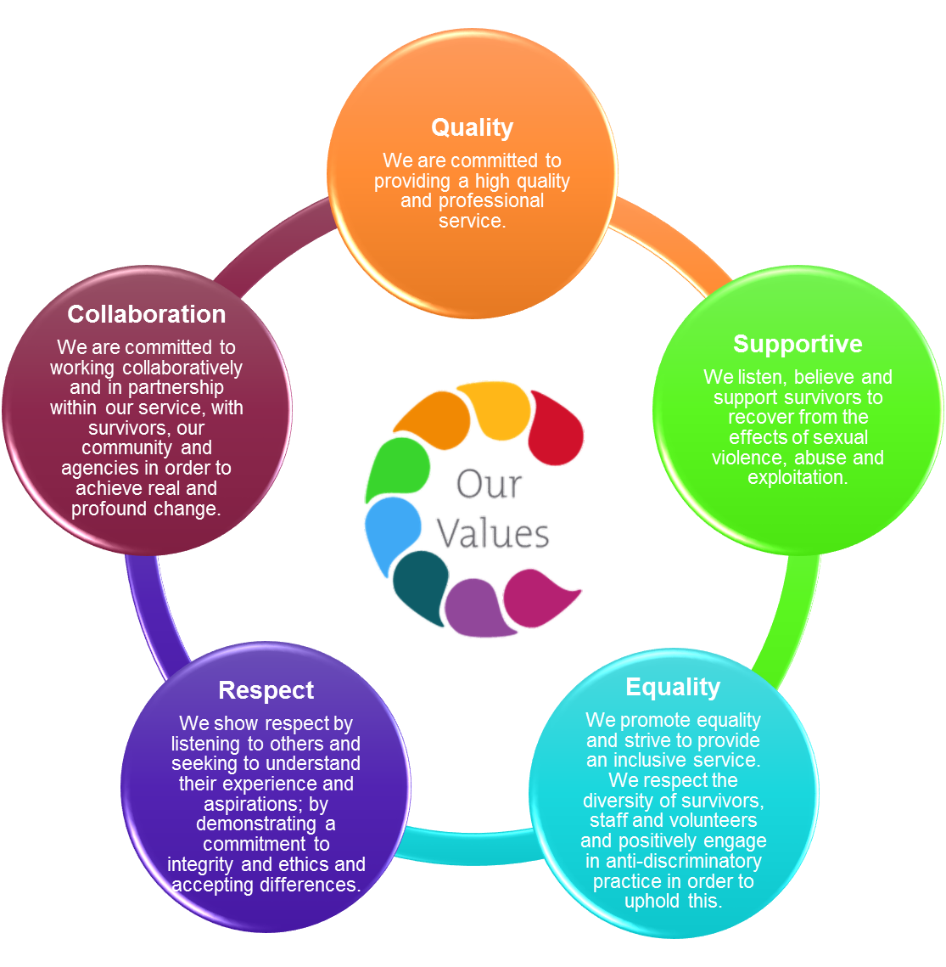

OUR STRATEGIC PRIORITIES

ADVICE ON COMPLETING YOUR APPLICATION FORM

As part of WRASAC’s commitment to equal opportunities, candidates for each post are treated equally. Application forms are the only basis on which the first selection is made to decide whom to call for interview. Therefore, only information, which appears on the form (and continuation pages), can be considered. It is very important that your completed form contains both the information we want about your skills and experience and the information you want to give us. These advice notes are intended to help you to complete your form effectively.

1 Read all the information provided especially the job description and person specification. These outline the duties you would be expected to carry out in this post and lists the skills, knowledge and abilities that the short listing/interview panel will be looking for.

2 Section 4 asks you to note down your general experience and is the most important part of your application. This is your chance to explain why you are suitable for the job. It is not enough to say you have the experience – you must demonstrate experience and skills with specific examples. Relevant experience may be from your current or previous jobs or from out with formal employment.

3 We have lots of information about our service on our website www.wrasac.org.uk.

4 Do not send your CV in addition to or in place of a completed application form as it will not be considered by the short-listing panel.

5 A Protection of Vulnerable Groups and Non-Police Personnel Vetting is required as part of the job.

6 Completing the Equal Opportunities Monitoring Form is voluntary, but the information requested here is useful as it allows us to monitor the effectiveness of our policy of equal opportunities in employment.

7 All applicants must complete all parts of the application form.

8 Application forms must arrive on time, forms arriving late will not be considered.

9 References are normally taken up for the short-listed applicants before interview. If you do not wish one or all references to be taken up at that point please indicate on the relevant page. It is our policy not to make a job offer without taking up references.

Board of Governor’s Role
Responsible to: WRASAC
Purpose: The role of the Board is to safeguard and promote the values and mission of the Centre, to determine the strategy and structure of the Centre, to ensure the Centre operates in an effective, responsible and accountable manner and to ensure the effective functioning of the board
Board Secretary Role
The secretary is a trustee with a specific role on the board they will contribute to the work of the board and participate in discussions and debates within meetings and regarding papers. The trustee appointed to be secretary in WRASAC can be a voting or be a non-voting role.
Key Responsibilities are
- Organising of monthly board meetings and AGM – Annual General Meeting and any EGM – Exceptional General Meetings
- Support the preparation and circulating of the monthly board meetings and AGM and any EGM – Exceptional General Meetings agenda and papers.
- Take minutes of meetings of the monthly board meeting and AGM, and any EGM that are called. The Secretary will need to make sure that:
- there are spare copies of all documents needed for the meeting
- arrangements for any vote or poll which may be needed are in place
- the meeting is properly convened
- there is a quorum (and if required, that it is present throughout the meeting);
- apologies for absence are noted, and
- all decisions made at the meeting are minuted (if the result of a discussion is unclear, clarify decisions with the Chair during the meeting to ensure the minutes are accurate)
- If it appears that a matter has been overlooked, the Secretary should also draw this to the attention of the Chair.
- To ensure that the charity complies with the requirements of company law.
- Company secretary may also execute legal documents for the charity of authorised by the board
Board of Governors Estimated Time Commitment
Board meetings - Approx 4 hour per month
Budget/Finance meetings - Approx 2 hours per month

Expenses
WRASAC offers travel, childcare, dependent care costs and other relevant out of pocket expenses in line with WRASAC’s finance policy.
The following information is from the Ensuring Good Governance Rape Crisis Scotland – Information pack
The responsibility of the board members*
1. To safeguard and promote the values and mission of the Centre
• to understand, be committed to, and promote the aims and strategic objectives of the Centre and its core values as set out in the strategic plan
• to ensure the Centre acts at all times in line with its governing document, charity and company law (if appropriate) and all other relevant legislation
• to ensure organisational practices comply with Centre’s values, strategic objectives and its governing documents
2. To determine the strategy and structure of the Centre
• to work with staff to produce a strategic plan that meets the organisation’s agreed aims and intended outcomes
• to monitor, review and update the strategic plan to ensure it is fit for purpose
• to ensure the Centre has an appropriate structure in terms of governance, management and operation to meet its agreed aims and objectives
• to work with staff to develop a business plan which sets out a programme of activities that deliver the organisation’s strategic objectives
• to set and approve budgets to achieve the objectives established in the business plan and regularly monitor performance
3.To ensure the Centre operates in an effective, responsible and accountable manner
• to identify, establish, review and date policies and procedures required by law and to implement good organisational management and employment practices
• to ensure equality is main streamed within all Centre policies and practice
• to ensure the Centre is financially stable, and manages and accounts for its finances, assets and other resources efficiently in accordance with accounting and legal requirements
• to ensure the Manager is supervised, supported, and monitored
• to ensure paid workers and volunteer staff are inducted, supervised, supported, and monitored
• to consider carefully all information, advice, and reports presented, and request further information, including legal or specialist advice, where necessary
• to maintain and review the Centre’s system of delegated responsibility, internal controls, financial controls and performance reporting
• to ensure the accountability of the organisation as required by law to OSCR, the Inland Revenue, the Registrar of Companies, members, funders, and the public at large
4. To ensure the effective functioning of the board
• to work constructively with other board members to ensure they are an effective body acting in the interests of the Centre
• to specify in role descriptions the particular responsibilities and powers delegated to particular posts (e.g. Chair, Treasurer) or to any sub-group
• to recruit a board that reflects the membership and wider community that the Centre serves, and provides the range of skills and experience that the Centre requires to fulfil its objectives
• to take part in induction and other training identified by the board and/or manager
• to review and develop policies and procedures that determine the conduct of the board and its meetings
• to ensure conflicts of interest are declared and handled in accordance with policy
• to prepare for and attend board meetings and contribute to discussions and decision-making
• to keep informed of issues which affect the Centre, and promote the Centre externally as agreed with the board
• to participate in tasks as required over and above-board meetings
The Centre will support board members by providing
• induction, training, and opportunities for development
• regular, accurate and relevant information on all aspects of the organisation
• encouragement to question decisions and disagree in a constructive manner
• access to support and guidance to become more effective

Women’s Rape and Sexual Abuse Centre

BOG Secretary Application Form (2023)

Name:

Address:

Postcode:

Email:

Mobile / Daytime number

Please answer the following questions as fully as you are able. (Please continue on another sheet if necessary.

What attracts you to becoming part of WRASAC’s Board of Governors?

2. What skills or qualities will you bring to WRASAC’s Board of Governors?

3. How do you feel you will benefit from being a volunteer on our Board of Governors? e.g. career development, work experience, meeting people etc..

4. WRASAC is a feminist organisation, reflecting on our Vision, Mission and Values, how would you feel about working with the organisation?

5. What questions or concerns, if any, do you have about becoming a volunteer with WRASAC?

6. Are you related to any employee or board member of WRASAC Dundee and Angus? Yes / No If yes, please provide details:

7. Are you or have you ever been a member of WRASAC Dundee and Angus Board of Directors? Yes / No If yes, please provide details:

8. Where did you see this vacancy advertised

References: Please note these can be character references.

Please note we will contact referees prior to interview.

Referee name:

Address:

Postcode:

Relationship to applicant:

Referee name:

Address:

Postcode:

Relationship to applicant:

Signed:

Date:

Please contact WRASAC on (01382) 205556 if you have any questions about any part of this application.

Please return completed application form to:

WRASAC Sangobeg House, 4 Francis Street, Dundee, DD3 8HH or

e-mail to recruitment@wrasac.org.uk

