

[](http://www.google.com/url?sa=i&rct=j&q=&esrc=s&source=images&cd=&cad=rja&docid=ONTlhgiBGp3OTM&tbnid=u-3_E07tAcEK0M:&ved=&url=http://ywcanewbritain.org/volunteer/&ei=McqxUqfAIcaQhQeJg4HIDw&bvm=bv.58187178,d.ZG4&psig=AFQjCNEPyOLJWw9fgpdpMwNW8LKkhi9oqQ&ust=1387469745976330)





**Board of Governors Recruitment Pack**

WRASAC Dundee & Angus is a company limited by guarantee, registered with OSCR and registered in Scotland as company number SC241372 and charity number SC009070.

Business: 01382 205556

Support: 01382 201291

info@wrasac.org.uk

support@wrasac.org.uk

www.wrasac.org.uk

Dear Applicant

We are delighted that you are considering a role of Trustee of WRASAC.

This pack is designed to give you a background of our service, the opportunities and challenges which lie ahead for us and to give you a better idea about what the role of Board of Governors entails.

Demand for support from survivors of sexual violence, abuse and exploitation has grown considerably over the last few years, a trend that is likely to continue. To that end, we have recently undergone series operational and governance changes to ensure that our organisation is fit for purpose.

To underpin this, our Board is currently in the process of undertaking our Good Governance Award ensuring that we stay at the forefront of best practice of strong and effective governance.

An exciting future lies ahead for us. As a Trustee we feel sure that you will find it both a rewarding and enjoyable experience. If you believe you can contribute to the continued growth and development of WRASAC, I hope that you will apply to become a Trustee and look forward to hearing from you.

Please don’t hesitate to contact our CEO, Sinéad Daly, on (01382) 205556 if you would like any further information.

Your completed application should be submitted via email by sending it to [recruitment@wrasac.org.uk](mailto:recruitment@wrasac.org.uk).

We look forward to receiving your completed application form.

**Please note only women need apply under Schedule 9, Part 1 of the Equality Act 2010**

Yours sincerely

Angela Wilson

Chair, WRASAC – Dundee & Angus

[](http://www.google.co.uk/url?sa=i&rct=j&q=&esrc=s&source=images&cd=&cad=rja&uact=8&ved=0ahUKEwio7vf0xuvNAhUCLsAKHeRtBJ4QjRwIBw&url=http://media.edfenergy.com/r/1057/edf_energy_accredited_by_the_living_wage_foundation&psig=AFQjCNEmpf-RNlA24FxfRgPUSS8wessuhA&ust=1468331389090766)

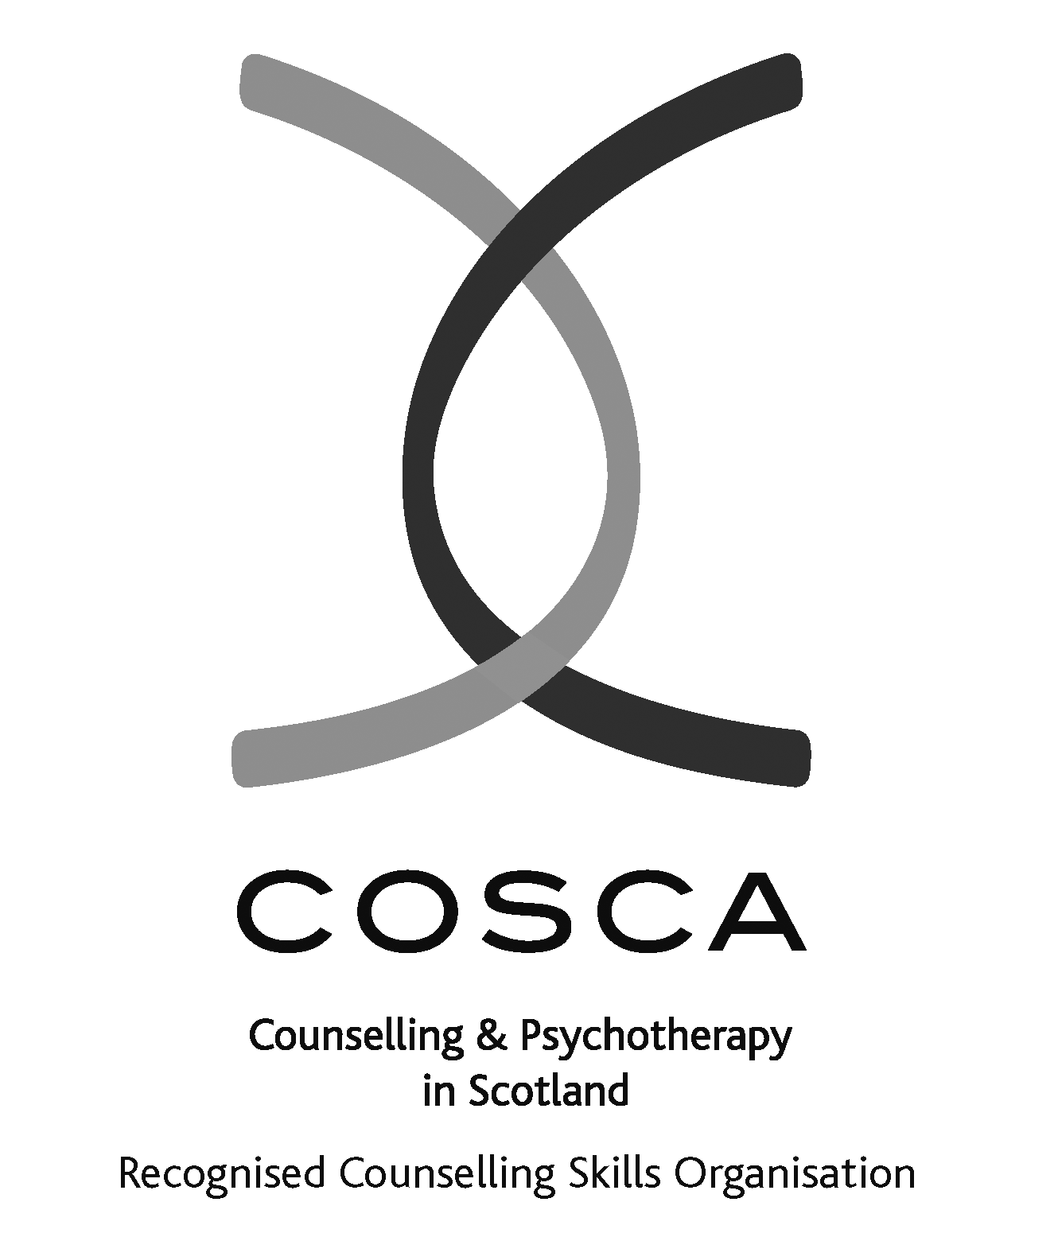

**2 Dudhope Street, Dundee, DD1 1JU**

WRASAC Dundee & Angus is a company limited by guarantee, registered with OSCR and registered in Scotland as company number SC241372 and charity number SC009070.

**About our service**

The Women’s Rape and Sexual Abuse Centre – Dundee and Angus (WRASAC) has been supporting survivors of rape, sexual abuse and exploitation and raising awareness about the damaging effects of sexual violence since 1984. We are a registered charity and a company limited by guarantee.

WRASAC has a dynamic team of 15 staff members, 12 volunteers and an annual income of just under £500,000 per year.

We provide a range of services to survivors of sexual violence, abuse and exploitation including:

**Advocacy:**

Works with survivors who are thinking about or are engaging with the Criminal Justice System. This includes support to report to the police, with court appearances, accessing the Sexual Assault and Referral Network (forensic examination for those not wishing to report in immediate aftermath of a sexual assault) and supports them with any civil protective orders.

**Dundee and Angus Young Survivors (DAYS)**

This service offers confidential and professional, emotional and practical support to all young survivors - of all gender identities - aged from 11 to 18; who have experienced sexual violence at any time; and who live in Dundee or Angus.

**Vice Versa**

Offers support and advocacy to women involved in prostitution and commercial sexual exploitation.

**Women’s Support Service**

Provides trauma informed support to survivors in a one to one and group setting. We have an Outreach Support Service that operates in Rural Angus.

WRASAC also works in a variety of ways to improve service provision to all survivors regardless of where they may present for support. We participate in many partnerships across Dundee and Angus, Scotland and even across Europe.

Most importantly, though, we are in the business of working within our communities to change attitudes so we can, in the longer term, prevent and reduce sexual violence from happening in the first place. We do this through:

**Prevention Work**

We have a dedicated Prevention Worker who works in schools, colleges and youth settings in Dundee and Angus delivering the Rape Crisis Scotland Prevention Pack.

**Training and Awareness Raising**

We provide a monthly Information Session to staff from Dundee and Angus. We also provide training on a range of topics including, dealing with disclosures, understanding sexual violence and dealing with trauma. Additionally we run community awareness raising events, like our Reclaim the Night march each year.

# **Vision, Values and Strategic Priorities**

In 2017-18, after a long period of reviewing and consulting with staff, volunteers, trustees, survivors and partner agencies we developed our new Strategic Plan and updated our Vision, Mission Statement and Values.

# **Our Vision**

For a world free from sexual violence, abuse and exploitation and a society in which everyone has equality, freedom and choices to live the lives they want and thrive.

# **Our Mission**

To support survivors who have experienced any form of sexual violence, abuse or exploitation in their lives.

To promote equality and raise public awareness of the routes of sexual violence and its damaging and life-changing effects.

# **Our Values**

We believe first and foremost that perpetrators of rape, sexual abuse and exploitation are responsible for their actions – not survivors.

We are a feminist organisation which means we recognise that all forms of rape, sexual abuse and exploitation are acts of violence, that disproportionately affects women and children, involving the abuse of power and control, are a breach of human rights and are fundamentally rooted in gender inequality.

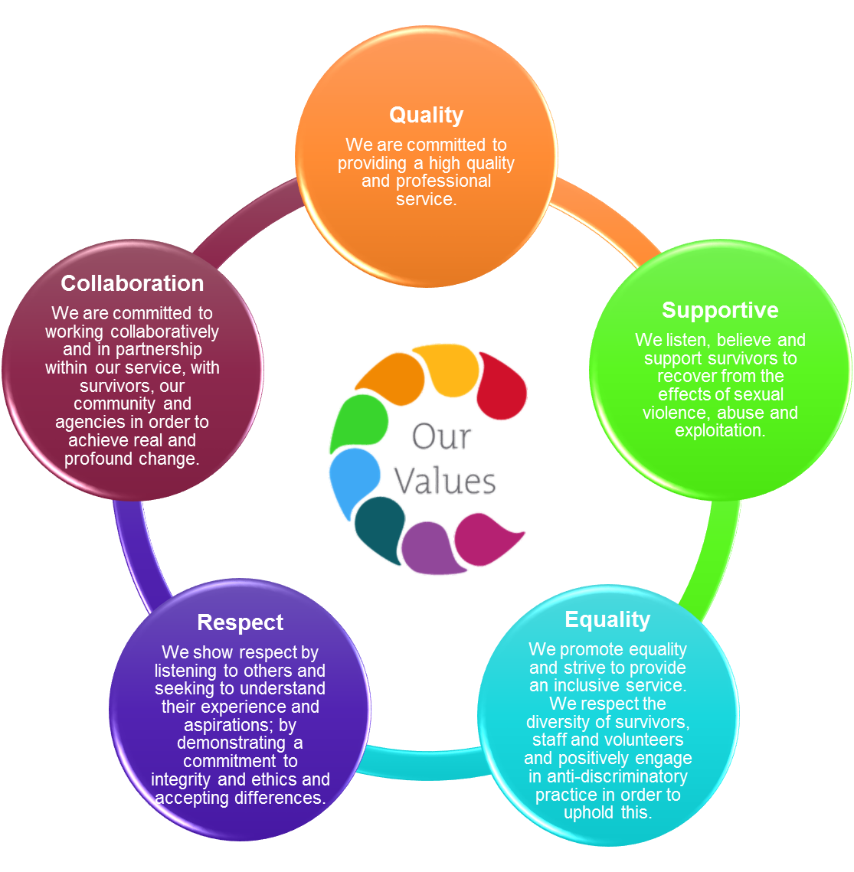

# **Our Strategic Priorities**

**Organisational Structure**

The Board of Governors is elected from the members of WRASAC. The Board members are volunteers. The Board of Governors have full responsibility for the financial, legal and personnel matters of WRASAC.

In 2013 we changed from a collective to a managed structure within the organisation and have maintained a consultative and collective approach. This change had the full support of all staff and volunteers (see our organisational chart below)



# **Job Description - Trustee**

**Job Title: Trustee**

**Responsible to:** WRASAC members and works closely with the Chair and CEO.

**Purpose**: The role of the Board is to safeguard and promote the values and mission of the Centre, to determine the strategy and structure of the Centre, to ensure the Centre operates in an effective, responsible and accountable manner and to ensure the effective functioning of the board.

**Responsibilities of the post:**

* to ensure that the organisation complies with its governing document “Articles of Association”, and any relevant legislation or regulations, including charities legislation.
* to ensure that the organisation pursues its objectives as defined in its governing document
* to ensure the organisation applies its resources exclusively in pursuance of its objectives. The organisation must not spend money on activities which are not included in its own objectives, no matter how worthwhile or charitable those activities are)
* to contribute actively to the board of trustees' role in giving firm strategic direction to the organisation, setting overall policy, defining goals, setting targets and evaluating performance against agreed targets
* to safeguard the good name and values of the organisation
* to represent the company at functions and meetings as appropriate
* to declare any conflict of interest while carrying out the duties of a trustee
* to be collectively responsible for the actions of the organisation along with other trustees
* to ensure the effective and efficient administration of the organisation
* to abide by the equal opportunities policy
* to ensure the financial stability of the organisation
* to protect and manage the property of the organisation and to ensure the proper investment of the charity’s funds
* to make sure the organisation is properly insured against all reasonable liabilities
* to contribute to the appointment and ongoing development and support to staff, including performance monitoring, where appropriate of members of the senior management team.
* to work in accordance with OSCR good practice guidance.

Other duties In addition to the above statutory duties of all trustees, each trustee should use any specific knowledge or experience they have to help the board of trustees reach sound decisions. This will involve:

* Scrutinising board papers
* Leading discussions
* Focusing on key issues
* Providing guidance on new initiatives
* Attend meetings, and to read papers in advance of meetings
* Attend sub-group meetings as appropriate
* Participate in other tasks as arise from time to time, such as interviewing senior managers, helping with fundraising
* Keep informed about the activities of the organisation and wider issues which affect its work

# **Time commitment and location**

* Our board meets a minimum of 6 times a year with additional time for reading papers and other communications. Other events, such as our annual conference and AGM, will increase this commitment.
* Board meetings are held at the organisation’s premises: 2 Dudhope Street, Dundee, DD1 1JU

New trustees will receive a full induction and should expect to allocate half a day this. Trustees are expected to attend all board meetings.

**Expenses**

WRASAC offers travel and other relevant out of pocket expenses in line with our finance policy.

# **Person Specification**

* a commitment to the mission and values of WRASAC
* a willingness to meet the minimum time requirement
* integrity
* strategic vision
* good, independent judgement
* an ability to think creatively
* a willingness to speak their mind
* an understanding and acceptance of the legal duties, responsibilities and liabilities of trusteeship
* an ability to work effectively as a member of a team and to take decisions for the good of WRASAC.

The board of trustees collectively needs skills and experience in the following areas:

* financial management, income generation and enterprise
* public policy and public affairs
* national and local voluntary sector
* national and local government and statutory bodies
* delivering digital products and services
* human resource management
* volunteering management
* evaluation and impact reporting
* experience in delivering digital technology