**Recruitment Pack**



Team Leader Women’s Support Service

Business: 01382 205556

Support: 01382 201291

Text: 07515288171

info@wrasac.org.uk

support@wrasac.org.uk

www.wrasac.org.uk

Dear Applicant

Thank you for your interest in applying for a post with Women’s Rape and Sexual Abuse Centre. Please find enclosed the following documents:-

* Advice on completing your application form
* Job Description and Person Specification
* Application form

**Please do not send a curriculum vitae as this will not be considered.**

Please note, all applications and relevant recruitment documents will be held confidentially and destroyed after 6 months, apart from documents relating to the successful applicant.

Your completed application should be submitted via email by sending it to [recruitment@wrasac.org](mailto:recruitment@wrasac.org).uk.

The closing date for applications is on **Monday 13th August at 12noon.**

We look forward to receiving your completed application form.

Yours sincerely

Sinéad Daly

Manager



Project partly funded by The Volant Charitable Trust administered by Foundation Scotland

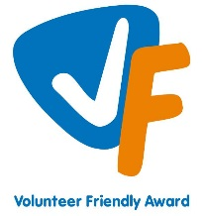[](http://www.google.co.uk/url?sa=i&rct=j&q=&esrc=s&source=images&cd=&cad=rja&uact=8&ved=0ahUKEwio7vf0xuvNAhUCLsAKHeRtBJ4QjRwIBw&url=http://media.edfenergy.com/r/1057/edf_energy_accredited_by_the_living_wage_foundation&psig=AFQjCNEmpf-RNlA24FxfRgPUSS8wessuhA&ust=1468331389090766)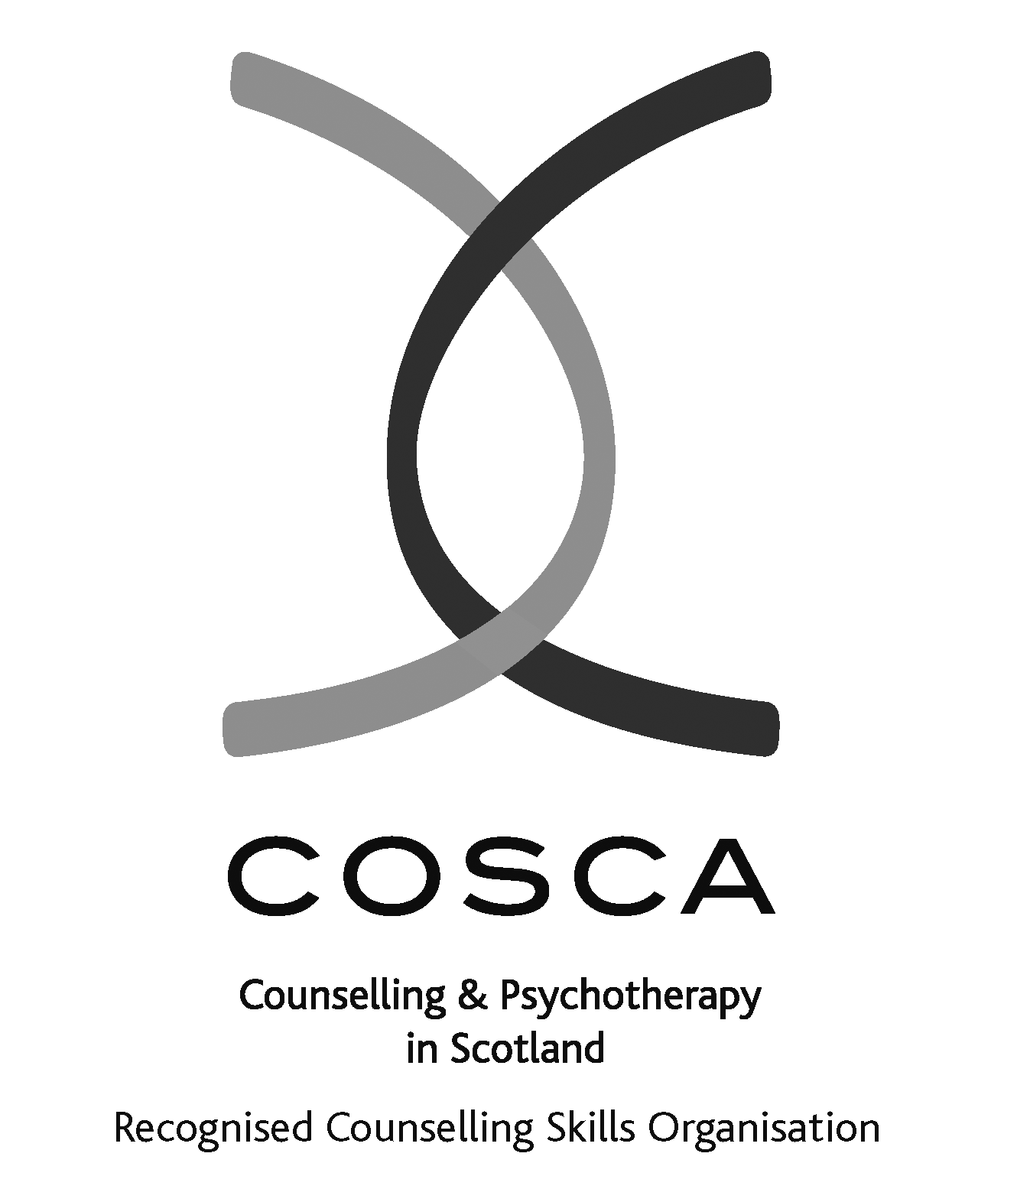

**2 Dudhope Street, Dundee, DD1 1JU**

WRASAC Dundee & Angus is a company limited by guarantee, registered with OSCR and registered in Scotland as company number SC241372 and charity number SC009070.

# ADVICE ON COMPLETING YOUR APPLICATION FORM

As part of WRASAC’s commitment to equal opportunities, candidates for each post are treated equally. Application forms are the only basis on which the first selection is made to decide whom to call for interview. Therefore only information, which appears on the form (and continuation pages), can be considered. It is **very** important that your completed form contains both the information we want about your skills and experience and the information you want to give us. These advice notes are intended to help you to complete your form effectively.

1 Read all the information provided especially the job description and person specification. These outline the duties you would be expected to carry out in this post and lists the skills, knowledge and abilities that the short listing/interview panel will be looking for.

2 The application form will be photocopied so that the form should be completed in black ink or typescript.

3 Section 4 asks you to note down your general experience and is the most important part of your application. **This is your chance to explain why you are suitable for the job.** It is not enough to say you have the experience – you must demonstrate experience and skills with specific examples. Relevant experience may be from your current or previous jobs or from out with formal employment.

4 Should you need to use an additional sheet of paper, please indicate the name of the post on the top of the sheet. **Do not send your CV in addition to or in place of a completed application form as it will not be considered by the short-listing panel.**

6 Completing the Equal Opportunities Monitoring Form is voluntary but the information requested here is useful as it allows us to monitor the effectiveness of our policy of equal opportunities in employment.

7 All applicants must complete all parts of the application form.

9 Application forms must arrive on time forms arriving late will not be considered.

10 References are normally taken up for the short listed applicants before interview. If you do not wish one or all references to be taken up at that point please indicate on the relevant page. It is our policy not to make a job offer without taking up references.

Information about WRASAC

**Brief History**

The Women’s Rape and Sexual Abuse Centre (WRASAC) offers free, confidential support for women, young women and girls, as well as boys between the ages of 12 to 18, who have been raped, sexually abused or sexually exploited at any time in their lives. The centre was initially established in 1984 as Dundee Rape Crisis Centre by Dundee Women’s Aid after they identified a need for a service to provide support to women who had experienced rape or sexual assault.

For the first 10 years the Centre depended on donations and volunteers however in 1994, funding was secured for three years for two workers to set up a Young Women’s Project. This project was successful and secured out first independent premises in 1998. Also in 1994 the Centre was successful in securing Urban Aid funding for a community outreach project. 23 years later this project has been hugely successful and has developed into our Women’s Safety Project funded by the Dundee Partnership.

In 1999 the orgaqnisation changed its name to Women’s Rape and Sexual Abuse Centre to reflect the fact that the majority of women utilising the Centre’s services are adult survivors of child sexual abuse. Only a very small percentage of women call for help immediately after being raped, sexually abused or sexually assaulted. It is more likely that women seek support months or even years after the abuse due to the effects and stigma suffered when trying to disclose abuse. In December 2002 WRASAC became a charity with limited company status.

The organisation is now funded by a number or funders including the Rape Crisis Specific fund, the Violence against women fund, the Big Lottery and Comic Relief. We rely on a range of donations from trusts on a regular basis. Applying for funding on a regular basis is one of the challenges we have to maintain and develop the service.

**Organisational Structures**

The Board of Governors is elected from the members of WRASAC. The Board members are volunteers. The Board of Governors have full responsibility for the financial, legal and personnel matters of WRASAC.

In 2013 we changed from a collective to a managed structure however within the organisation we have maintained a consultative and collective approach. The change had the full support of all staff and volunteers and the organisation now has a Manager, Young People Service Team Leader, Finance Worker, Admin and Information Worker, Women’s Support Workers, Sexual Violence Prevention Worker, Advocacy Worker and volunteers.

**What we offer**

* One to one support, telephone support, support by letter or e-mail and support groups
* Helpline open 6 hours per week Monday to Friday (answering machine at other times)
* Free complementary therapies for service users.
* Support to family, friends and partners of survivors via our helpline
* Support and information to workers from any agency supporting survivors
* A book and video lending library
* Leaflet packs
* Issue based training to agencies
* Workshop sessions for women’s groups
* Training for women who want to volunteer
* Vice Versa service for women involved in prostitution, offering emotional and practical support, drop in, and access to drug treatment.
* Outreach support service for women living in rural Angus.
* Drop-in for both WRASAC and Vice Versa services.
* Group work through Pathways Group and Creative Group
* Service User Forum
* Volunteer Forum

**Geographical Area**

* Dundee and Angus, Some parts of Perthshire and North-East Fife.

Job Description & Person Specification

**Job Title**

**Service Women Support Services Team Leader**

**JOB PURPOSE:** The Team Leader has overall responsibility for ensuring survivors receive high quality support and that staff / volunteers are well supported to do their work through high quality line management. The Team Leader is expected to work closely with the Manager and to deputise for when necessary.

**RESPONSIBLE TO:** WRASAC Manager

**Salary:** £30,795 - £33,432

**Hours:** 35 hours per week

**Location:** Dundee

**Holiday Entitlement:** 33 Days plus 5 Public Holidays (rising to 36 Days after 3 years’ service)

**Pension:** Employer contribution at 6% to pension fund.

**MAIN DUTIES**

**Support work**

1. Provide counselling, support and advocacy to survivors with complex mental health via one to one, group, helpline, email and letter, including carrying a caseload.
2. To develop and review assessment processes for survivors wishing support.
3. To advocate on behalf of survivors.
4. Establish and maintain effective working relationships with staff from other agencies to ensure holistic needs of survivors are met.
5. To review and develop appropriate support tools and resources for survivors.
6. Ensure high quality record of work with survivors on our online Case Management System – OASIS.

**Supporting and supervising staff & volunteers**

1. Provide high quality line management to Women’s Counselling and Support staff and volunteers. This includes provision of support and supervision and mentoring, oversee caseloads and allocated projects to relevant Support Staff and Volunteers who work with survivors.
2. Conduct annual appraisals with supervised staff.
3. Ensure accurate, shared records of all supervision notes and appraisals are kept.
4. Ensure that external clinical/practice supervision is provided to all staff and monitor its usefulness and relevance making changes as required.

**Strategic leadership & operational management**

1. Support the manager in the development and implementation of the strategic plan as relevant to the Women’s Support Service.
2. To support the development and implementation of our fundraising strategy, including applying for and reporting to funders.
3. Responsibility for managing budgets of Women’s Support Service.
4. Deputise for the Manager when required.

**Evaluating, reporting and monitoring**

1. Objectively review the success and achievements against agreed targets, identifying strengths, weaknesses and areas for development.
2. Ensure all staff keep effective records and complete monitoring information in a timely manner.
3. To liaise with and provide reports and updates to the Manager and the Board of Directors’

**Quality and safety**

1. To undertake the role of Adult Support and Protection Officer for WRASAC services.
2. Ensure staff comply with all relevant legislation, policies and procedures.
3. Support staff to develop and share their practice through regular practice meetings.

**Managing yourself**

1. Model a resilient approach to working in the service demonstrating the importance of self-care and boundary setting.
2. Use appropriate workload management techniques and ensure work is delegated effectively to staff.

**Other duties**

1. To promote effective partnerships working with key stakeholders, including participation at relevant multi-agency / strategic partnerships.
2. Raise awareness of issues around rape, sexual abuse and exploitation through providing training, promotional events, talks etc.
3. To develop, maintain and represent positive, collaborative working relationships with all WRASAC staff.
4. Produce detailed annual action plans on specific areas of responsibility, identifying areas for growth and development and outlining measurable objectives

This job description is a broad picture of the post at the date of preparation. It is not an exhaustive list of all possible duties and it is recognised that jobs change and evolve over time. Consequently, this is not a contractual document and the post holder will be required to carry out any other duties to the equivalent level that are necessary to fulfil the purpose of the job.

**PERSON SPECIFICATION**

|  |  |  |  |
| --- | --- | --- | --- |
|  | ESSENTIAL REQUIREMENTS | DESIRABLE REQUIREMENTS | METHOD OF ASSESSMENT |
| **Professional / Educational Qualifications** | Relevant qualification in supporting survivors, for example, COSCA Counselling Skills and / or at least 3 years’ experience in providing trauma based models of support. | Diploma in Counselling or equivalent  Management / Leadership qualification | Certificates  Application |
| **Relevant work / other experience** | Significant experience in providing support to survivors using counselling support skills.  Experience of working with people with complex mental health issues.  Demonstrable experience of managing and supervising staff and/or volunteers.  Clear understanding of management, leadership and supporting frontline staff & volunteers  Experience in, and knowledge of service planning and development.  Experience of writing reports.  Experience of developing, delivering and evaluating training.  Experience of partnership working with external agencies. | Experience of writing funding applications  Experience in writing funding reports | Application  Interview  References |
| **Skills & Knowledge** | Demonstrates a knowledge of the impact of trauma on survivors and appropriate support tools / methods.  Knowledge of the impact of rape, sexual abuse and exploitation on survivors.  Clearly articulates an understanding and commitment to a feminist analysis of gender based violence.  Understanding and knowledge of Child & Adult Protection Legislation.  Demonstrates excellent interpersonal skills with a range of people including staff, service users, donors, volunteers and partner organisations  Understanding of qualitative and quantitative monitoring and reporting.  Good planning, organisational and prioritisation skills.  Skilled in use of digital technology and IT systems. |  | Application  Interview  References |
| **Personal Qualities** | An interest in social justice and a genuine desire to support those affected by rape, sexual abuse and / or exploitation.  A commitment to the values and work of WRASAC.  Demonstrates a resilient approach to the workplace and has clear strategies for managing self.  Evidence of a ‘can-do’ attitude, with the ability and willingness to problem solve, involving others when necessary.  High level of personal commitment to equality and diversity, and ability to work with partners and colleagues from a wide range of backgrounds. |  | Application  Interview  References |
| **Additional Job Requirements** | Member of PVG Scheme or willingness to become a member of the PVG Scheme with satisfactory scheme record and/or scheme record update.  Must be able to work flexibly (including evenings and weekends) to meet the needs of WRASAC.  All candidates must have the right to work in the UK  Occupational Requirement under Schedule 9 (part 1) of the Equality Act 2010 applies. Due to contact with service users the post holder must be female in accordance with the Sex Discrimination Act 1975 Part 7 (2) (e). | Full drivers licence and access to a car | Application  Interview |